##### A Software Engineering Project

##### On

Tour Management System

as the partial fulfilment of

**Semester -V study**

for the degree of

**Bachelor of Science (Computer Science)**

## (Affiliated to Veer Narmad South Gujarat University)

during the academic year 2022-2023.

### 

**Developed By: Guided By:**

Student Name Guide Name

Ayushi H Marakna Dr. Priti Patel



Sarvajanik Education Society

## Shree Ramkrishna Institute of Computer Education and Applied Sciences

## Behind P.T Science College, M.T.B. College Campus, Athwalines, Surat-395 001.

### 

### Sarvajanik Education Society

## Shree Ramkrishna Institute of Computer Education and Applied Sciences

# Behind P.T. Science College, M.T.B College Campus, Athwalines, Surat-395 001.

### CERTIFICATE

## DEPARTMENT OF COMPUTER SCIENCE

This is to certify that

Student name Exam no

Ayushi H Marakna 20204

has / have successfully completed his / her / their software engineering project work entitled

Tour Management System

as the partial fulfillment of

**Semester -V study**

for the degree of

**Bachelor of Science (Computer Science)**

## (Affiliated to Veer Narmad South Gujarat University)

during the academic year 2022-2023.

___________________ ____________________

#### Internal Project Guide HOD

#### Dept. of Computer Science

#### Date: ____________ Place: Surat

### University Examination:

**Examination No.: ____________**

**Signature of External Examiners: _______________________________**

**_______________________________**

_______________________________

**INDEX for Project Documentation**

|  |  |  |  |
| --- | --- | --- | --- |
| **SR.NO** | **CONTENTS** | | **Page. No** |
| **1.** | **Introduction** | | 1 |
|  | ∙ | Project Profile |  |
| **2.** | **System Introduction** | | 2 |
|  | ∙ | System Definition, Objective and scope |  |
|  | ∙ | Hardware & Software Requirements |  |
| **3.** | **Requirement Analysis & Modeling** | | 4 |
|  | ∙ | Expected working of system |  |
| ∙ | Data Flow Diagrams (DFD) |  |
| ∙ | Process Specification |  |
| ∙ | Data Dictionary |  |
| **4.** | **Design** | | 12 |
|  | ∙ | ER Diagram & Database Design |  |
| ∙ | System Flowchart |  |
| ∙ | Form & Report Designs (Screenshots) Layouts |  |
| **5.** | **Coding** | | 26 |
|  | ∙ | Coding Approach/style |  |
| ∙ | Code Snippets |  |
| **6.** | **Testing** | | 29 |
|  | ∙ | Testing Data Inputs ( Data Validations) |  |
| ∙ | Testing Operations (Actions on each screen) |  |
| **7.** | **Project deployement** | | 31 |
| **8.** | **New Tools/ Technologies learned/used** | | 32 |
| **9.** | **System Limitations/Restrictions and Dependencies/Constraints** | | 33 |
| **10.** | **Future Enhancement & Opportunities** | | 34 |
| **11.** | **Bibliography & References** | | 35 |

1. Introduction

System Profile

* + Project Title  Admission System
* Organization  Shree Ramakrishna Institute Of Education and Applied Sciences
  + Front -End tool  Visual Studio 2019(PHP) ,HTML, CSS, Bootstrap
  + Back -End tool  PHPMYADMIN
  + Project Category  Source System
  + Operating System  Windows 10 or above
  + Project Duration  2 Month
  + Project Guided By  Dr.priti patel
  + Developed By  Ayushi marakana

1. System Introduction
   1. System Definition, Objective and scope
      1. System Information: -

* Travel and Tourism Management System is an application which refers to managing systems of booking TRIP, FOOD FACITLITY. The booking is done your finger tip.
* Trip packages modules are also included in this system which would give a user convivence and also a detailed description about the trip. With this management system there will be more convivence to user for there trip. All these modules are able to help librarian to manage the library with more convenience and in a more efficient way as compared to library systems which are not computerized.
* Tourism is an activity done by an individual or a group of individuals, which leads to a motion from a place to another, with a purpose of entertaining which leads to an awareness of other civilizations and cultures.
* Tourism is mainly carried out for recreationaland leisure purposes.
* Trips are important globally as providing the facilities for recreation and entertainment, meeting and conferences and business transmission
* Hospitality is the provision of the accommodations, meals and drinks to those people who are out of their homes
  + 1. PROJECT OBJECTIVE: -
* Hospitality is the provision of the accommodations, meals and drinks to those people who are out of their homes
* No Physical Boundary
* Added Information Accessible Universally
* Round The Clock Availability
* Multiple Access
  + 1. System Scope: -
       - Login function accessed by only admin.
       - Admin can only add/delete student and add/delete faculty member.
       - Admin upload resources which would be store.
       - Admin also delete resources which they uploaded.
       - Student also upload resources and they also view it.
  1. Hardware & Software Requirements

Hardware:-

* Processor : Intel core i5 or above
* Ram : 2 GB or above
* Hard-Disk : 100 GB or above

Software:-

• Backend : MYSQL Database .

• Frontend : Visual Studio code 2019, HTML, CSS, JavaScript.

• Operating System : Windows 10 or above.

1. REQUIREMENT ANALYSIS
   1. Expected working of System
      * **Admin Module :** Admin can login with username and password which is already store in System database. Admin can add faculty member and view list of faculty member and remove them if admin want. Admin also add/delete Students.
        + Admin login
        + New package add
        + View package
        + Update package
        + Delete package

**User Module :**

* Student login with email id and password they also login

With the mobile number OTP. They can upload resource Delete and share it.

* + View Details
* **Login Module :** Admin and student login in this system.
  1. Data Flow Diagrams (DFD)
* CONTEXT LEVEL DFD:-

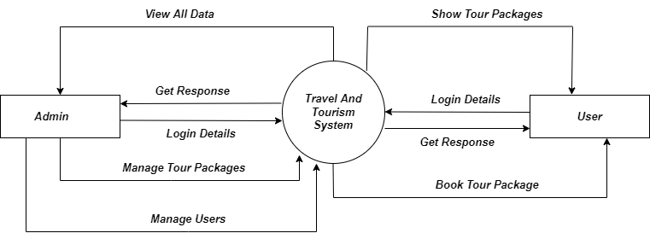

* **1ST LEVEL DFD FOR ADMIN:-**

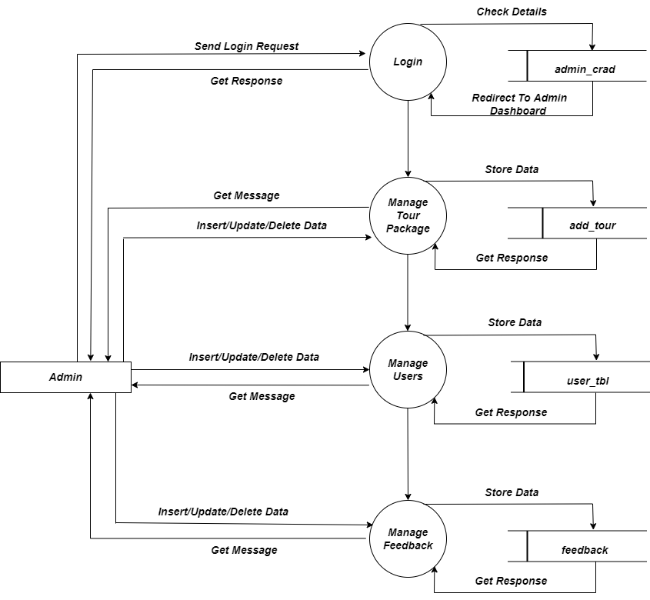

1st LEVEL DFD FOR USER: -

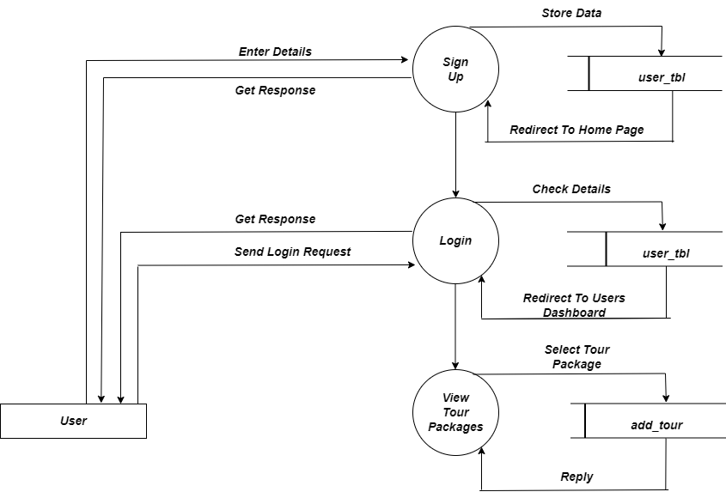

* 1. **Process Specification**
     + PROCESS 1.0:

|  |  |
| --- | --- |
| **Name:** | **Login** |
| Description: | This process is save all the information of the Faculty members and Admin like Userid , Password etc. |

* + - **PROCESS 1.0 FOR USER:**

|  |  |
| --- | --- |
| **Name:** | **Registration** |
| Description: | This process is save all the information of the user like name, email id.,mobile num and dob. |

* + - PROCESS 2.0 FOR USER:

|  |  |
| --- | --- |
| **Name** | **Login** |
| Description: | User can login with this system with use of email id and Password. |

* + - **PROCESS 3.0 FOR USER :**

|  |  |
| --- | --- |
| **Name** | **Manage Resources** |
| Description: | Student can manage details. They can add details which they saved. They have no permission to view details of other Students. |

* + - PROCESS 3.0 FOR ADMIN:

|  |  |
| --- | --- |
| **Name:** | **Manage Subject** |
| Description: | Admin can add package , update package also delete package |

* 1. Data Dictionary
* **Admin Table**

|  |  |
| --- | --- |
| **Name:** | Admin |
| **Alias:** | **Admin_crad** |
| **Where used/How used:** | Data use for particular login For admin |
| **Content Description:** | Admin_name+  Admin_pass+ |

* User Table

|  |  |
| --- | --- |
| **Name:** | User details |
| **Alias:** | User_tbl |
| **Where used/How used:** | user use this table for registration |
| **Content Description:** | Id+  Name+  Email+  Phone+  Address+  Pincode+  Dob+  Password+ |

**User Data Table**

|  |  |
| --- | --- |
| **Name:** | user data login |
| **Alias:** | User_login |
| **Where used/How used:** | user use this table for login |
| **Content Description:** | Email+  Password+ |

* feedback Table

|  |  |
| --- | --- |
| **Name:** | User details |
| **Alias:** | feedback |
| **Where used/How used:** | To store educational data and . |
| **Content Description:** | F_id+ ,name+ , email+ , subject + , msg+ |

* **Tour package Table**

|  |  |
| --- | --- |
| **Name:** | Tour package add |
| **Alias:** | Add_tour |
| **Where used/How used:** | Tour package add ,update ,delete |
| **Content Description:** | T_id+ photo+ tour_name+ price+ includes+ duration+ age+ month+ |

1. Design

E-R Diagram :

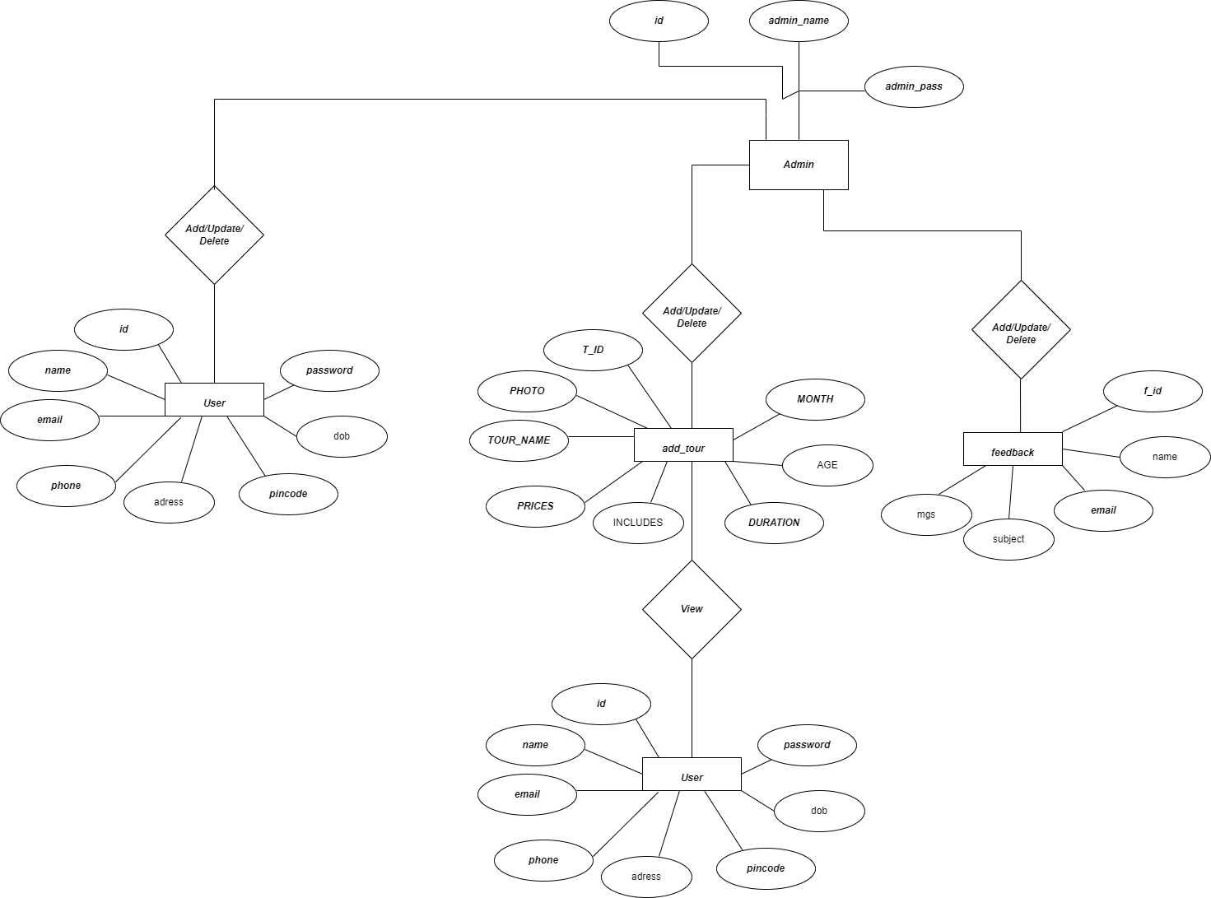

* 1. **Database design:**
     + Table Name : user_tbl

|  |  |  |  |  |
| --- | --- | --- | --- | --- |
| **Field Name** | **Data Type** | **Constraints** | **Field Size** | **Description** |
| **id** | Auto Number | Primary Key | 11 | Contains ID of user |
| **name** | varchar |  | 20 | Contains name of  user |
| **email** | varchar |  | 20 | Contains email of user |
| **phone** | bigint |  | 10 | Contains phone of user |
| **address** | varchar |  | 30 | Contains address of user |
| **dob** | Date |  |  | Contains dob of user |
| **password** | varchar |  | 20 | Contains password of user |
| **pincode** | int |  | 6 | Contains pincode of user |

* + - Table Name : feedback

|  |  |  |  |  |
| --- | --- | --- | --- | --- |
| **Field Name** | **Data Type** | **Constraints** | **Field Size** | **Description** |
| **f_id** | Auto Number | Primary Key | 11 | Contains ID of user |
| **name** | varchar |  | 20 | Contains name of user |
| **email** | Varchar |  | 20 | Contains email of user |
| **subject** | Varchar |  | 20 | Contains subject of  user |
| **mgs** | Varchar |  | 150 | Contains mgs of user |

* + - Table Name : add_tour

|  |  |  |  |  |
| --- | --- | --- | --- | --- |
| **Field Name** | **Data Type** | **Constraints** | **Field Size** | **Description** |
| **T_id** | int | Primary Key | 11 | Contains id of tour data |
| **photo** | varchar |  | 20 | Contains photo of tour |
| **Tour_name** | varchar |  | 20 | Contains name of tour |
| **price** | int |  | 20 | Contains price of tour |
| **includes** | varchar |  | 50 | contains includes of tour |
| **duration** | varchar |  | 20 | Contains duration of tour |
| **Age** | varchar |  | 20 | Contains age of tour |
| **month** | varchar |  | 20 | Contains month of tour |

* + - Table Name : **admin**

|  |  |  |  |  |
| --- | --- | --- | --- | --- |
| **Field Name** | **Data Type** | **Constraints** | **Field Size** | **Description** |
| **Sr_no** | int | Primary Key | 11 | Contains ID of admin |
| **Admin_name** | varchar |  | 20 | Contains name of admin |
| **Admin_pass** | varchar |  | 20 | Contains pass of admin. |

* 1. System Flowchart :
     1. **Admin Side :**

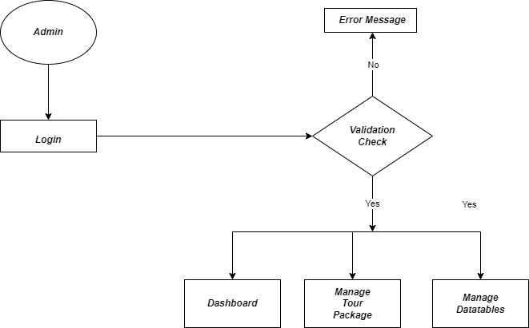

* + 1. **User Side :**

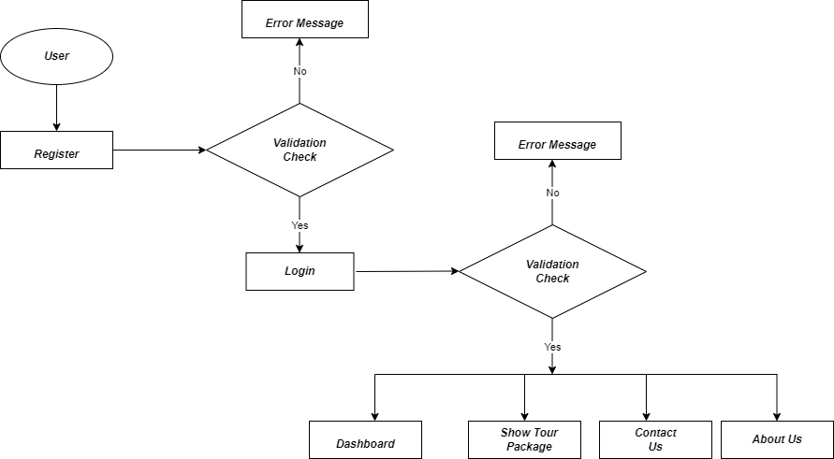

* 1. FORM AND REPORT DESIGN(SCREENSHOT)LAYOUT:
* Login Page For Admin
  + Login page used by admin to login in Admission system.
  + Login done with email and password of admin .

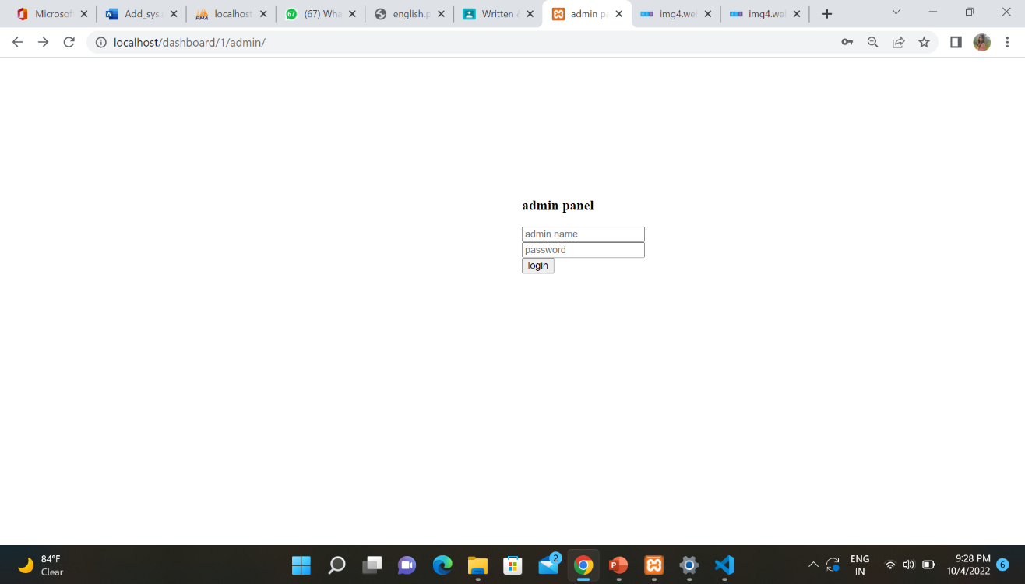

* Admin Dashboard
  + If admin is login in this system then admin redirected on Dashboard of admin.

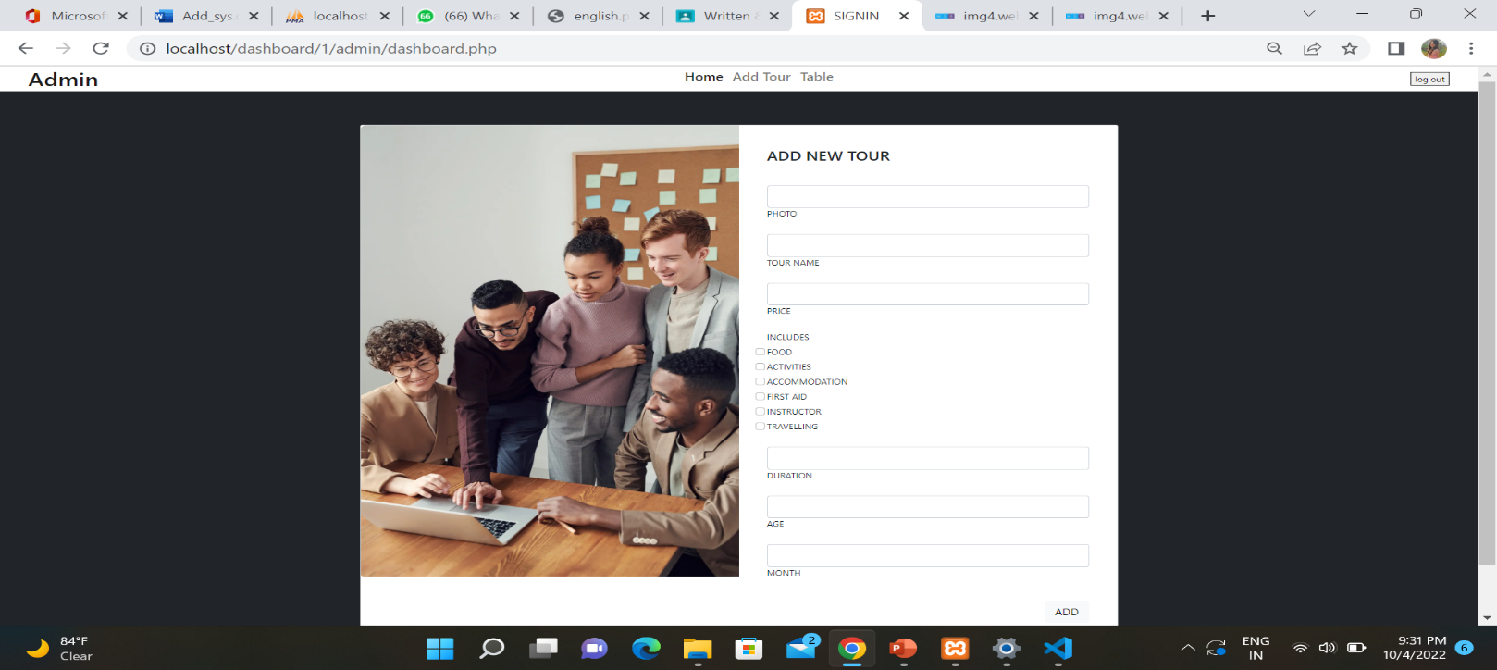

* package update and delete

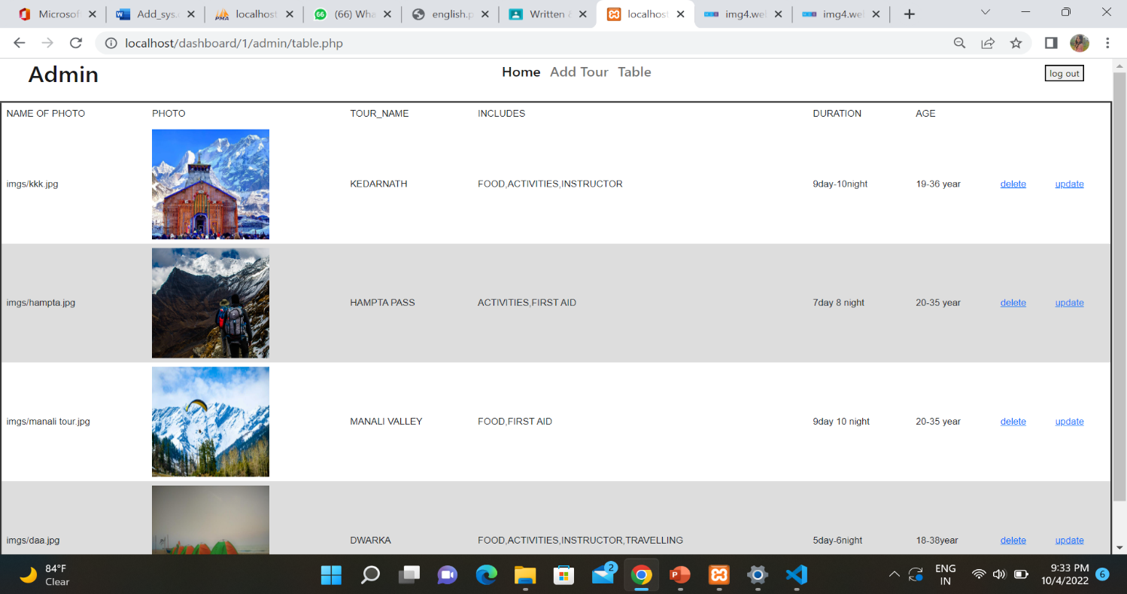

* Login Page For Student
  + This Login page used by the user only. Admin and can’t Use this page for login.
  + Login done with Email and Password.

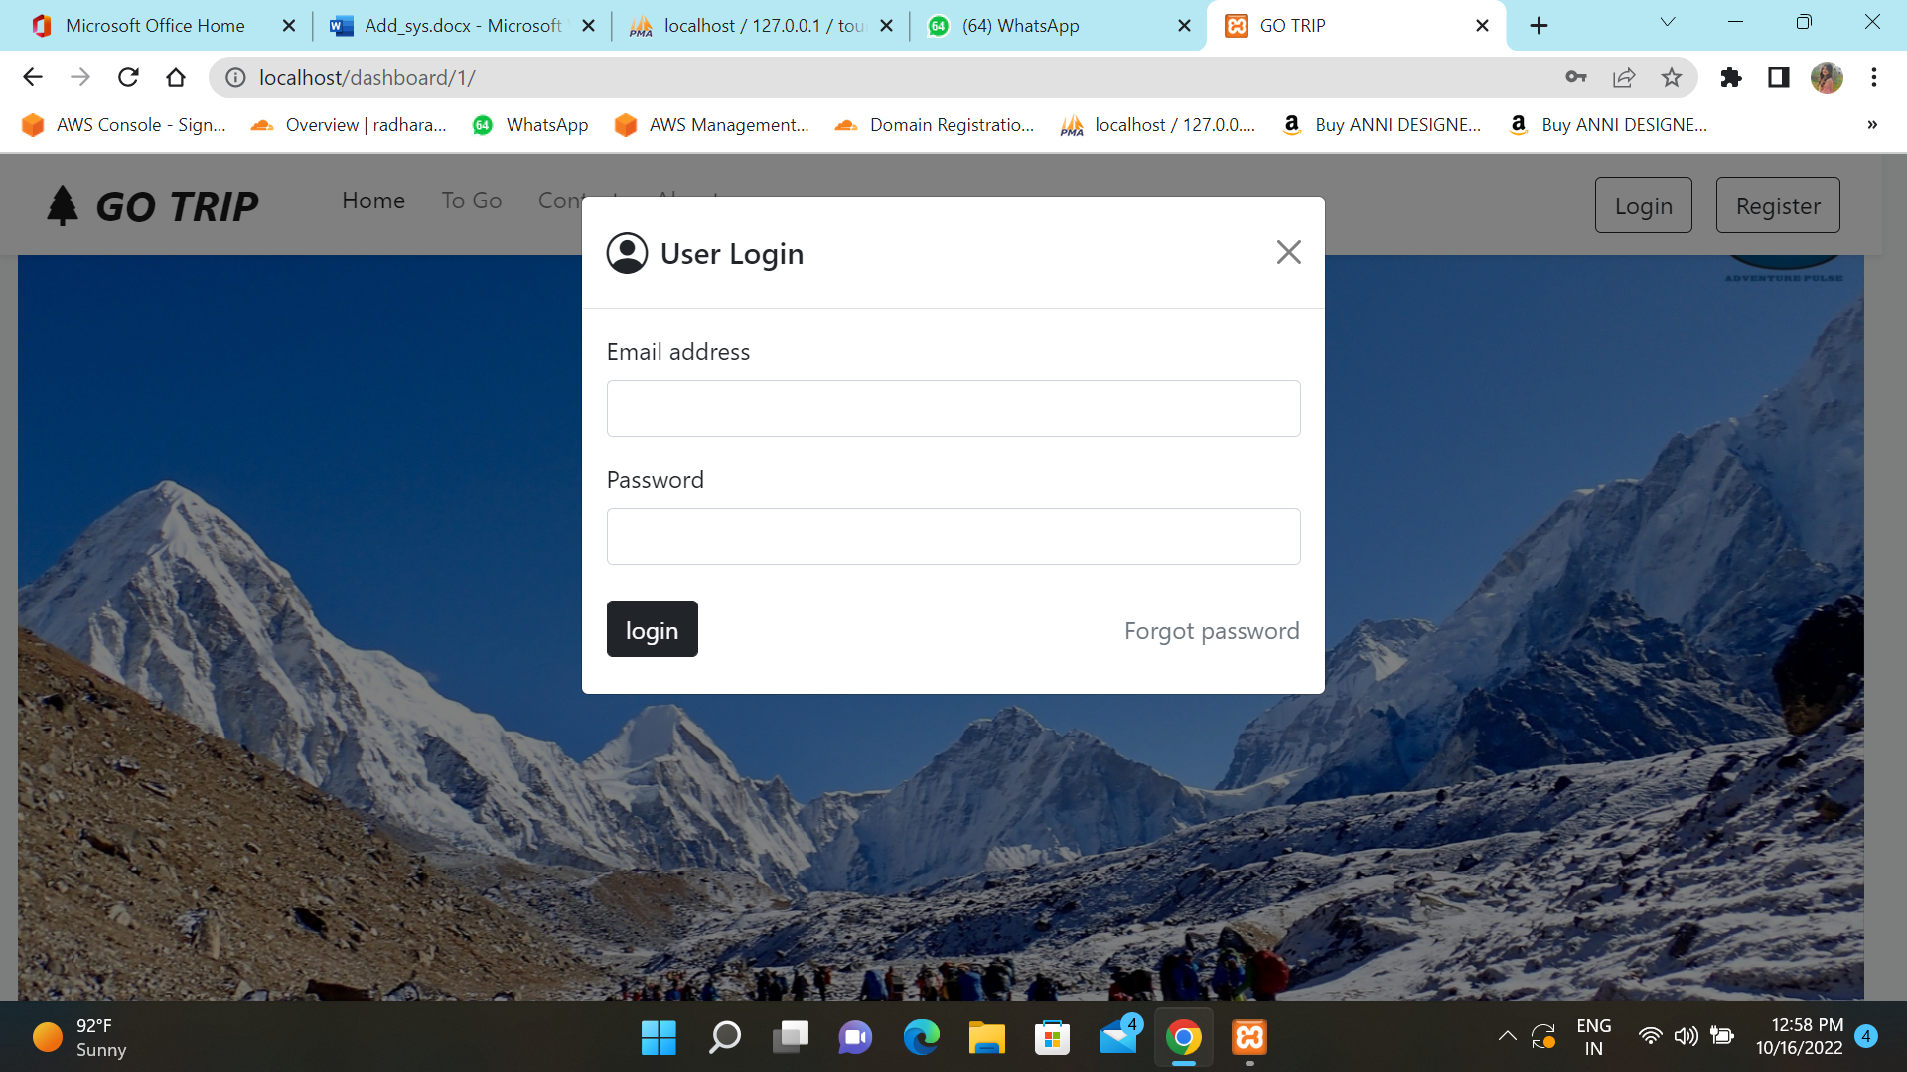

* User Register :

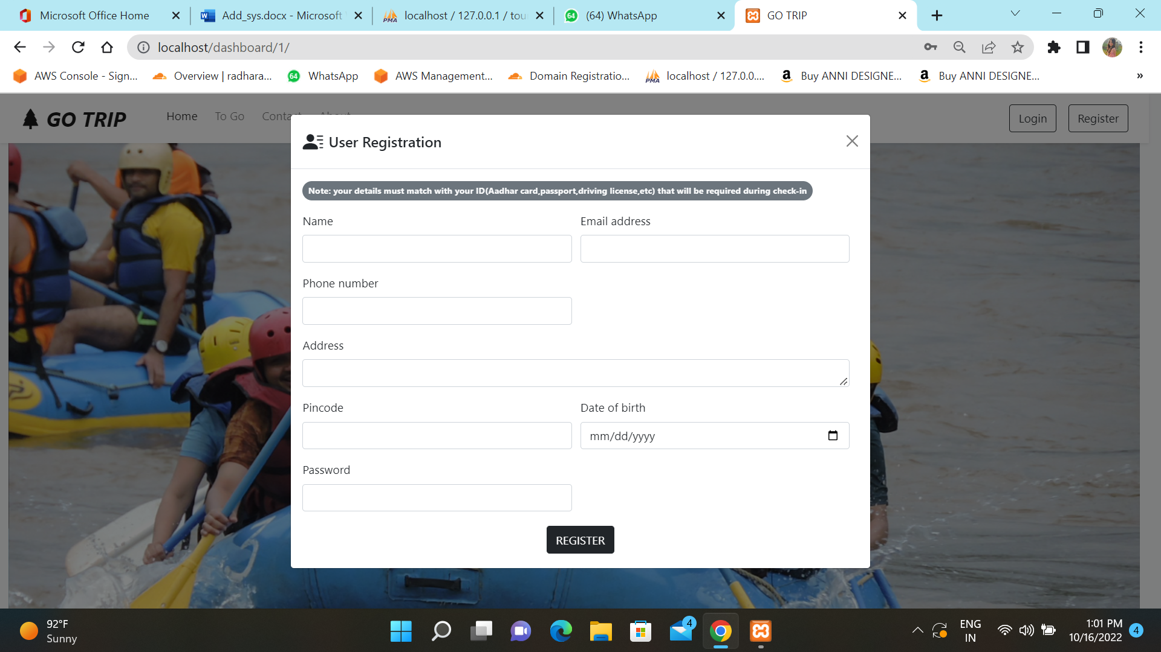

**dashboard details**

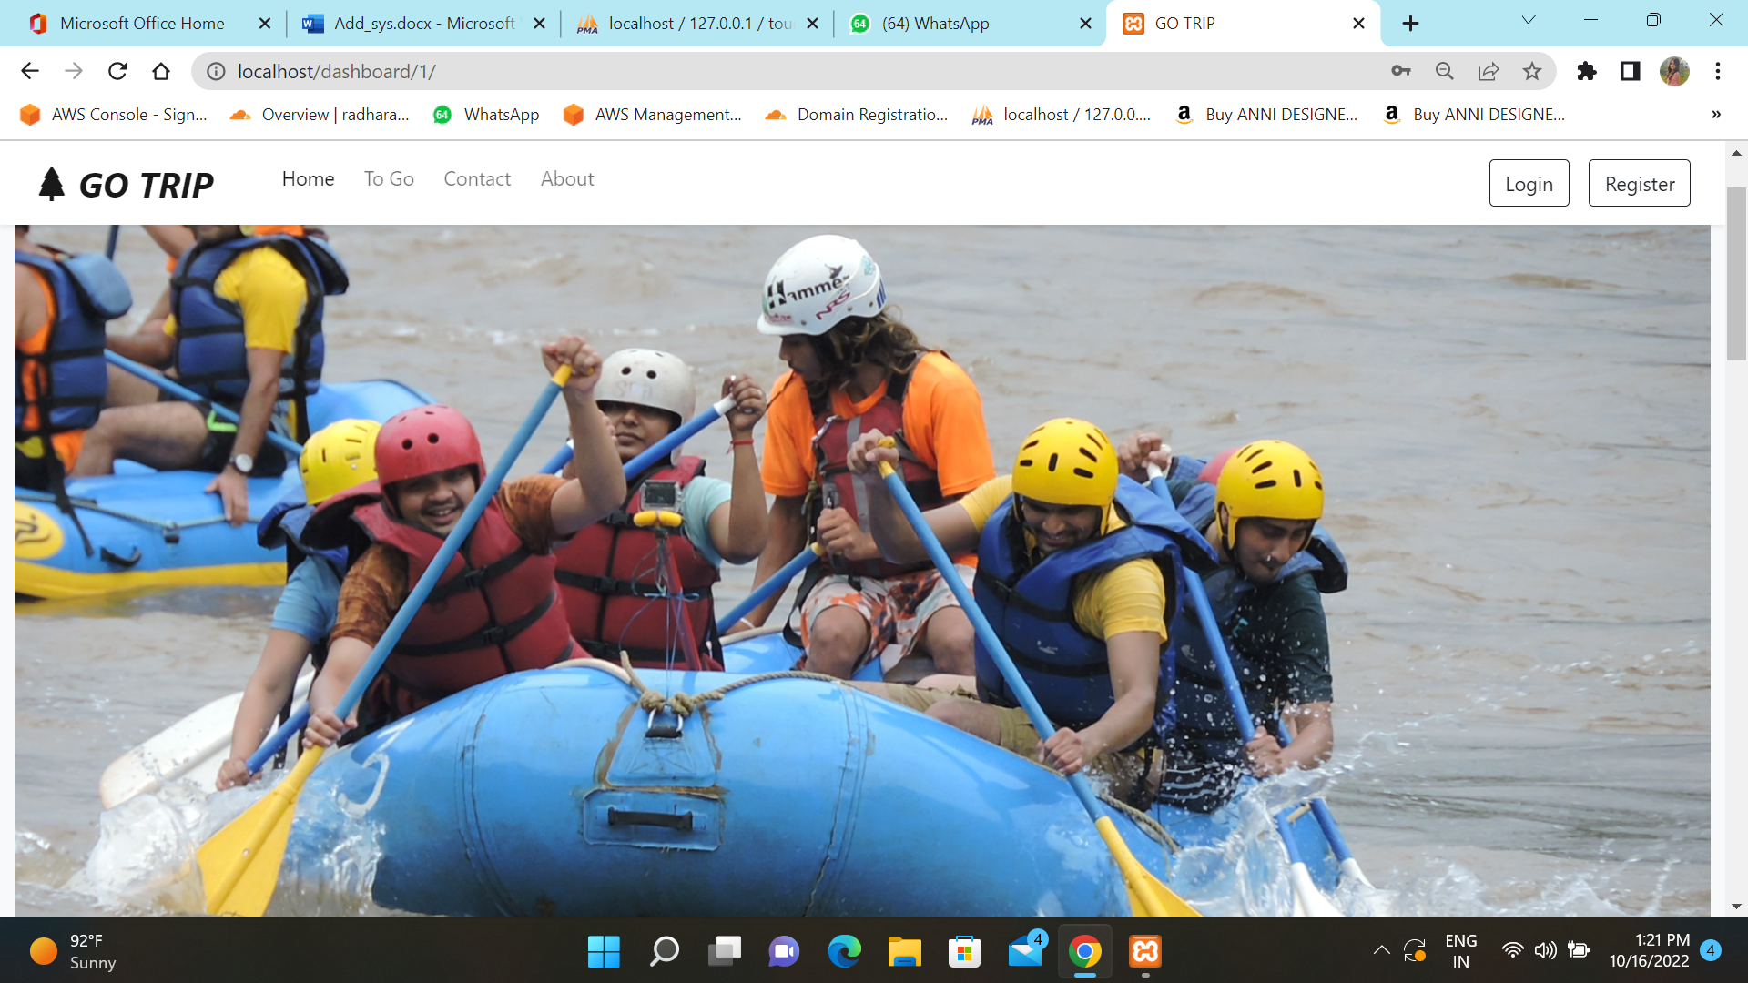

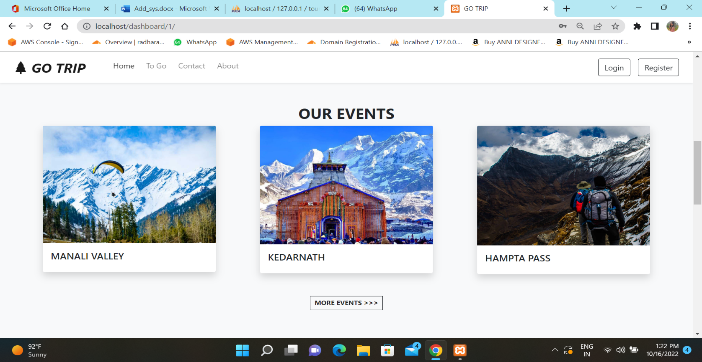

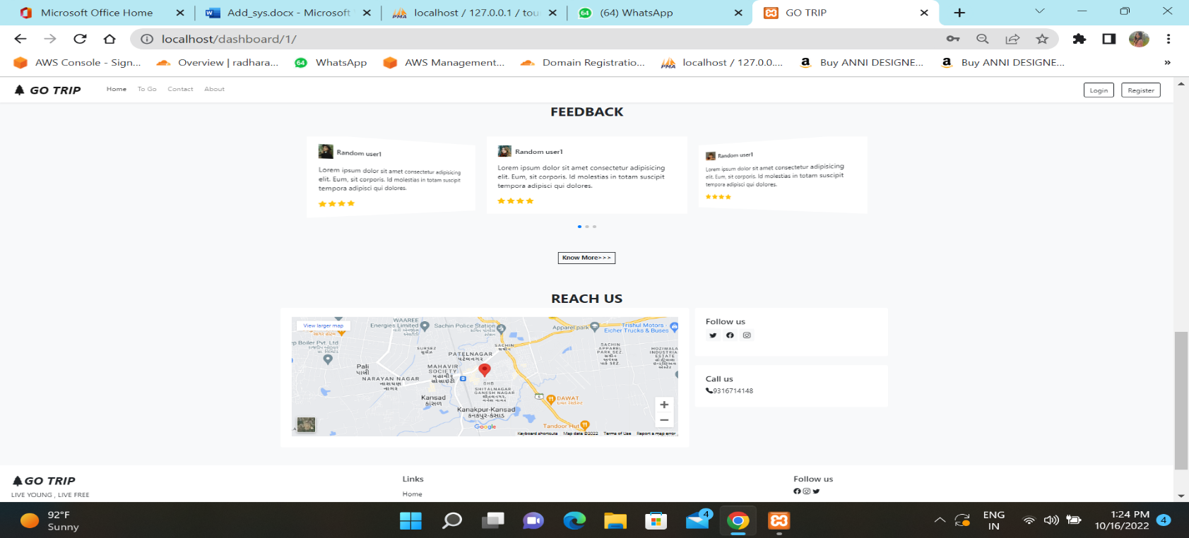

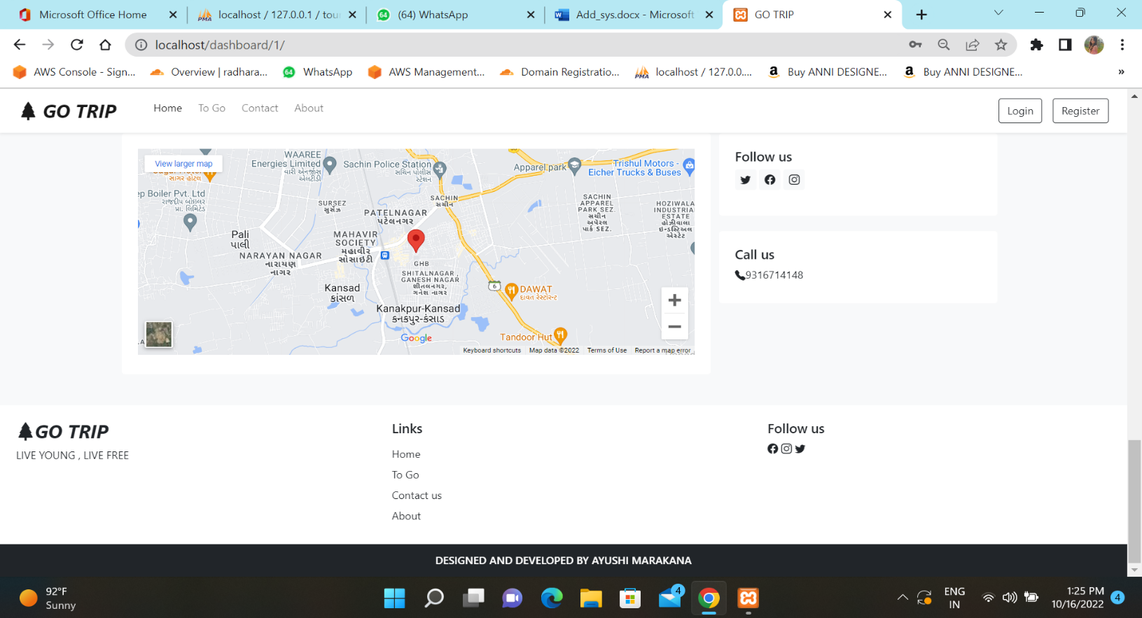

**Package show**

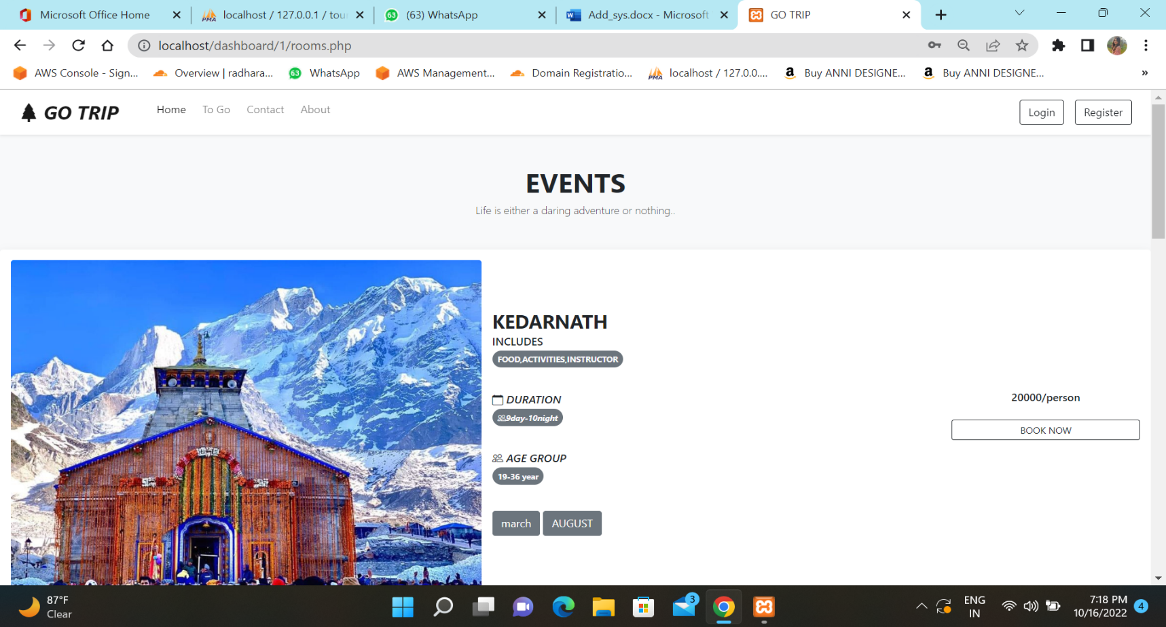

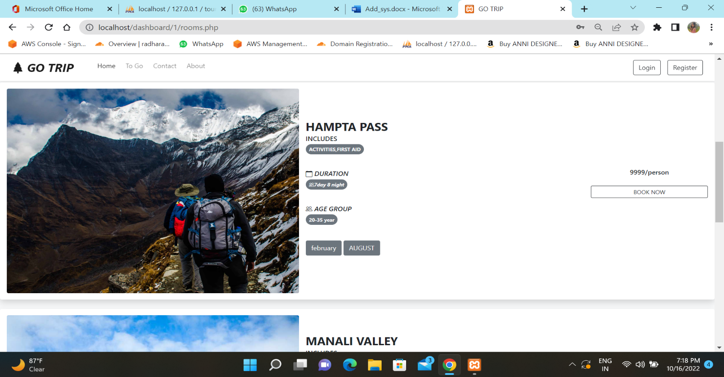

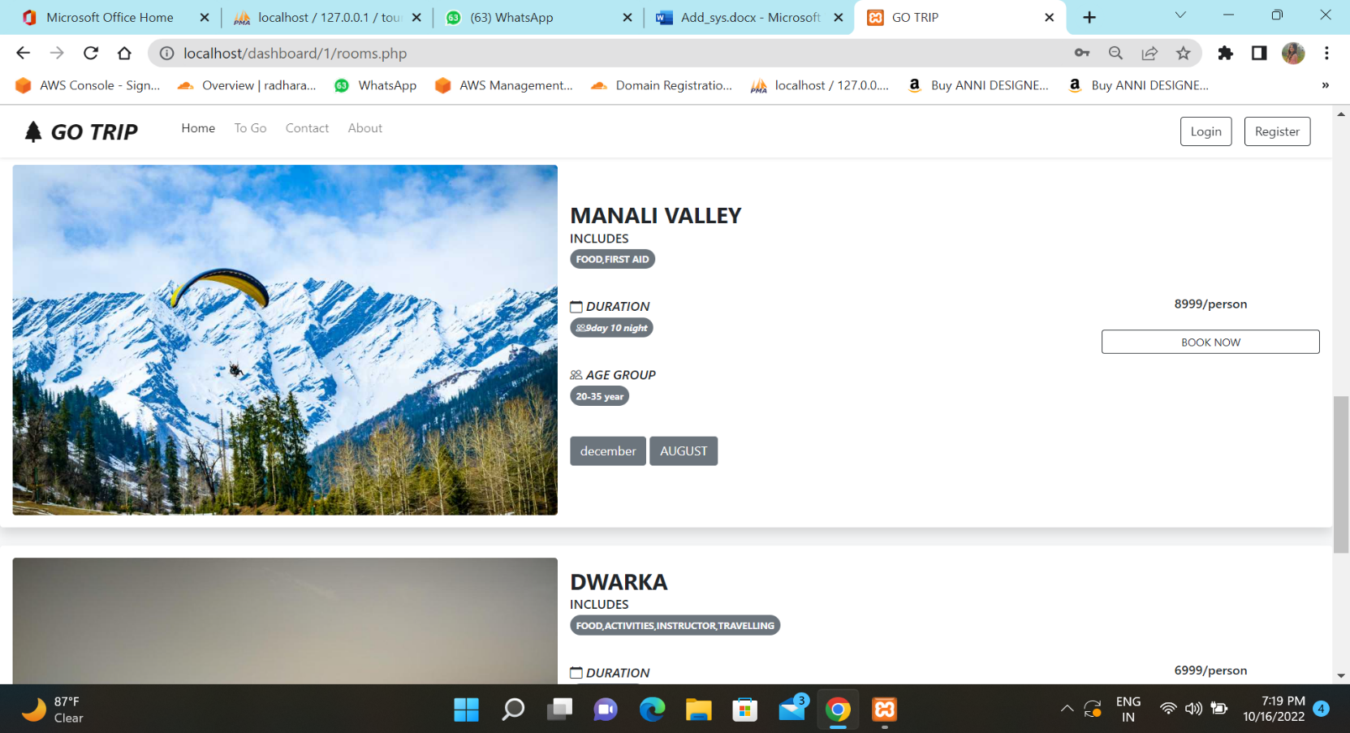

**Feedback**

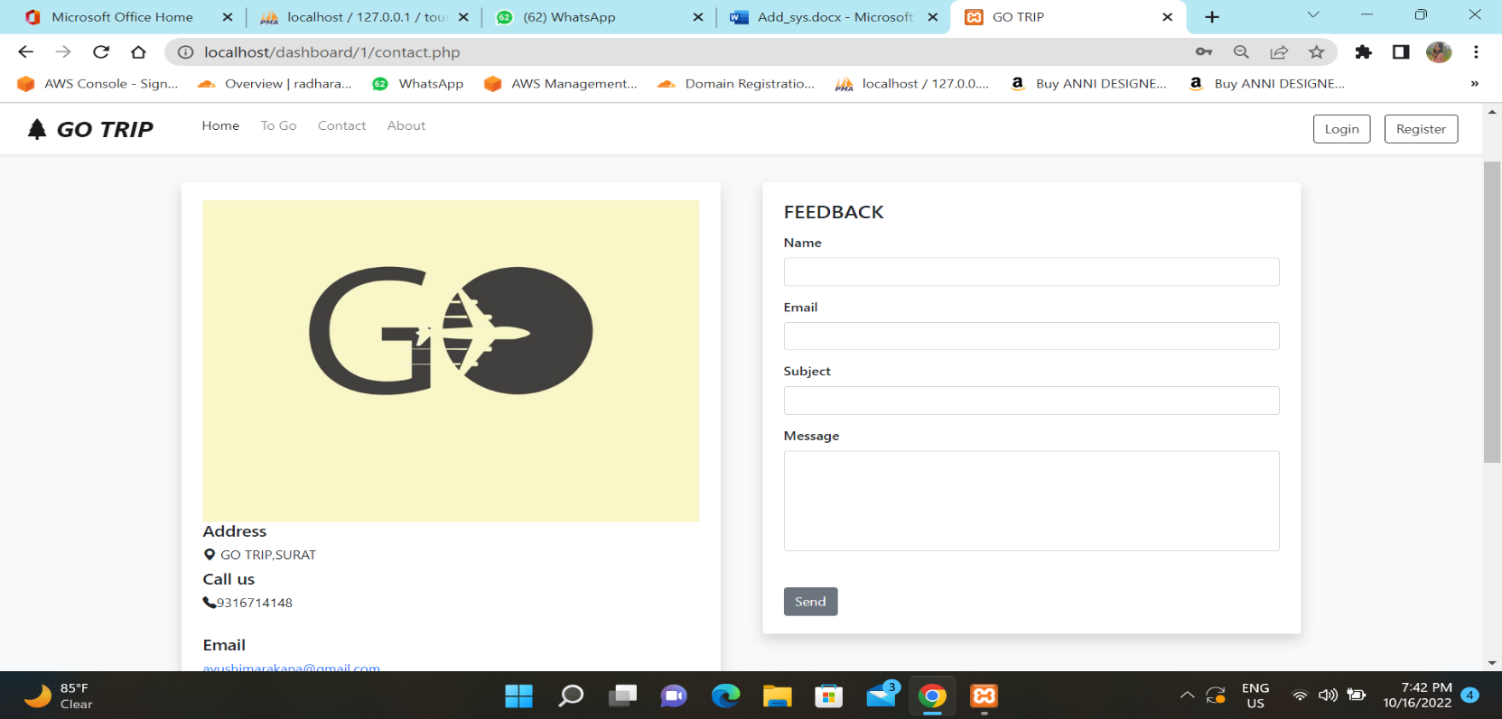

**About us**

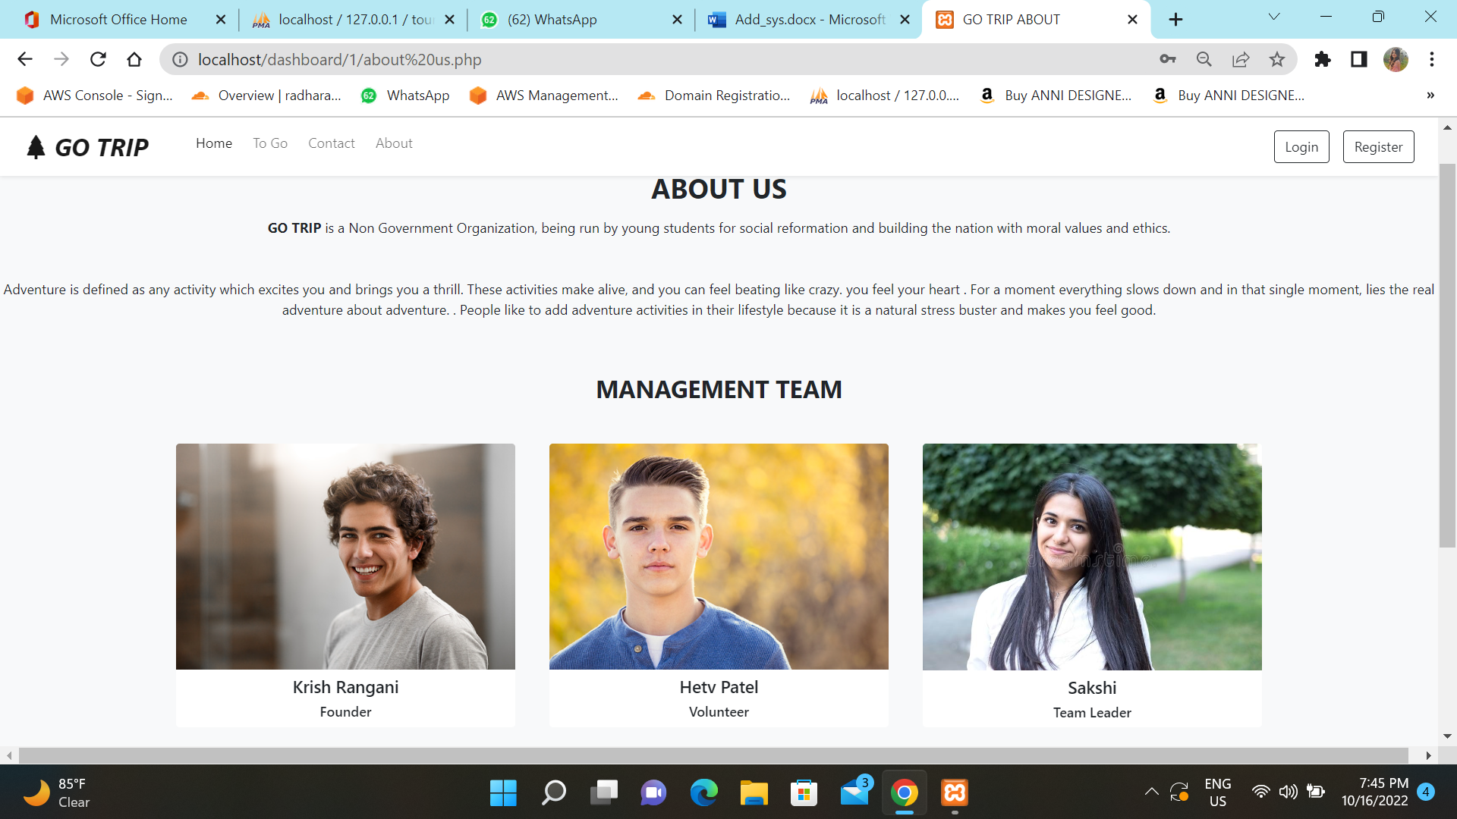

1. CODE
   * Index page

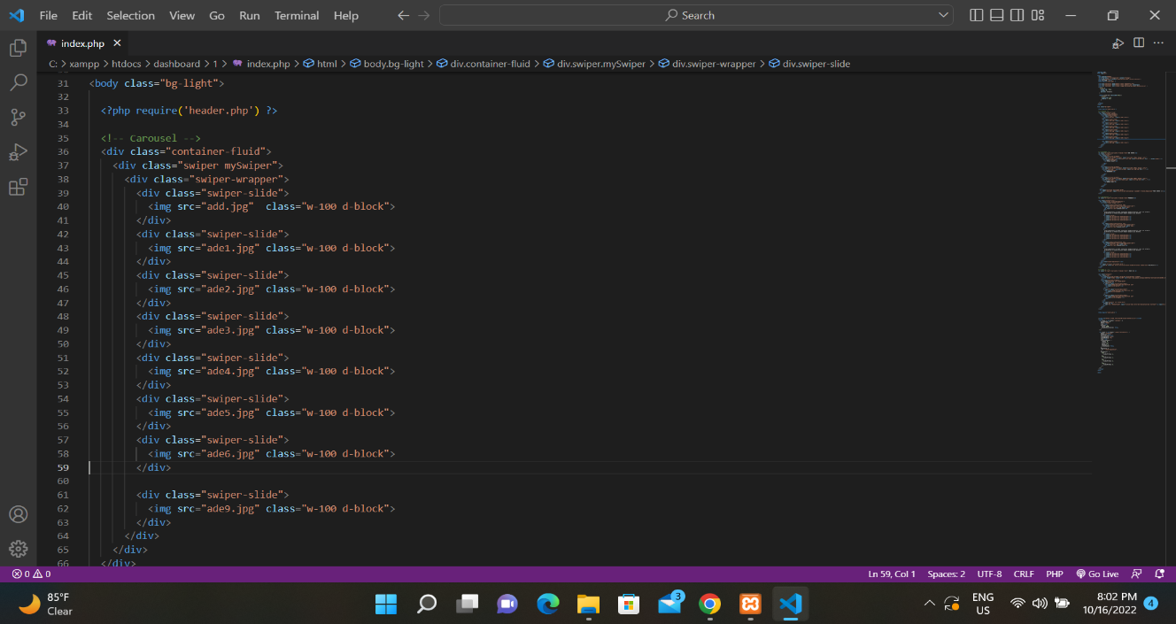

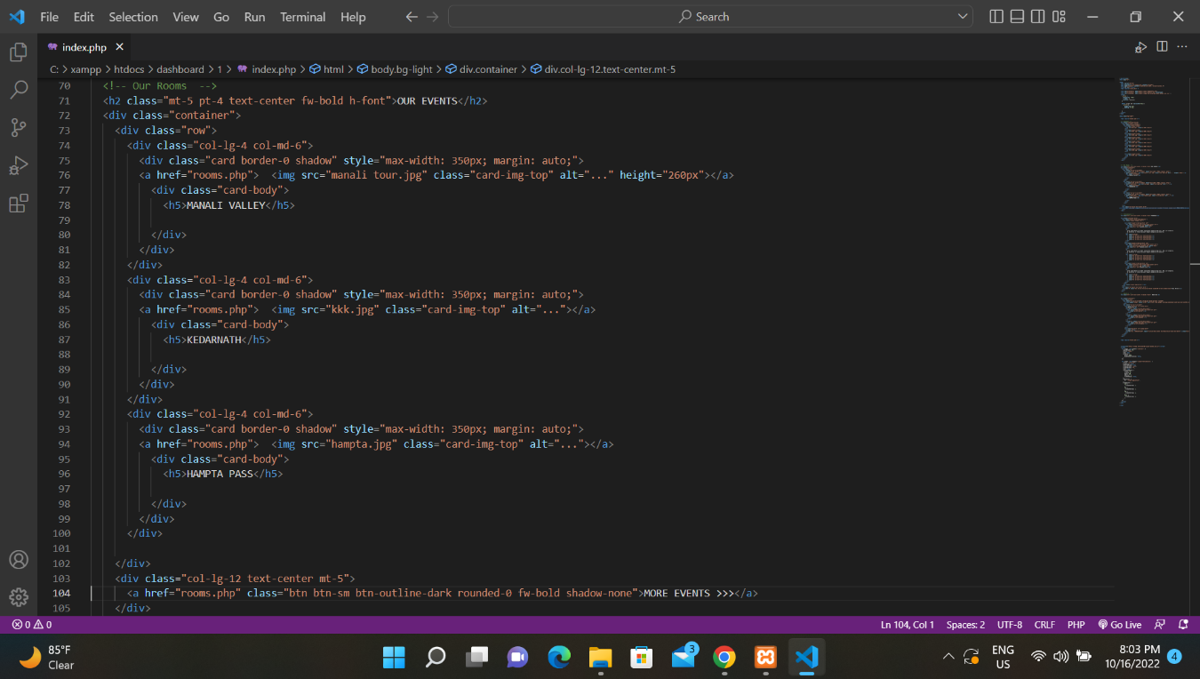 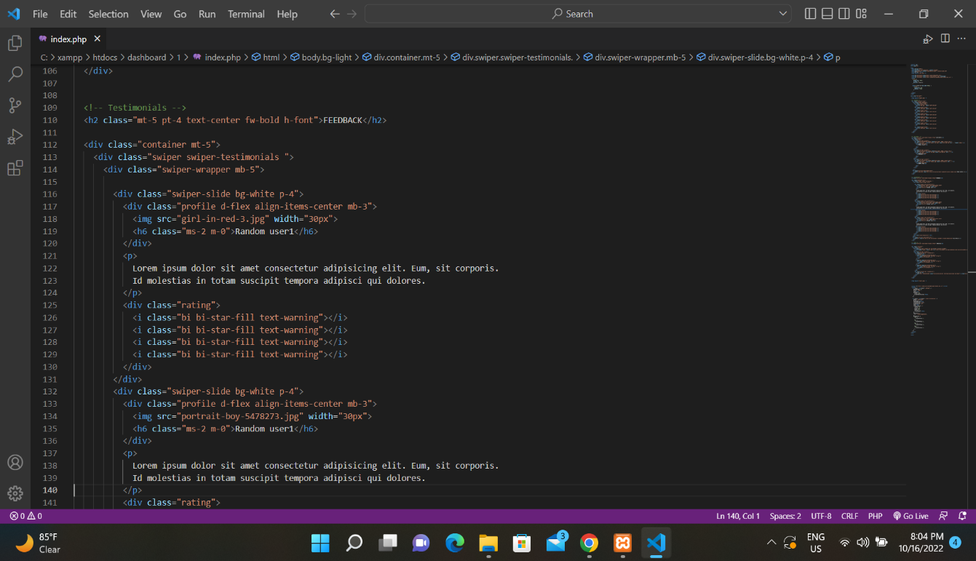

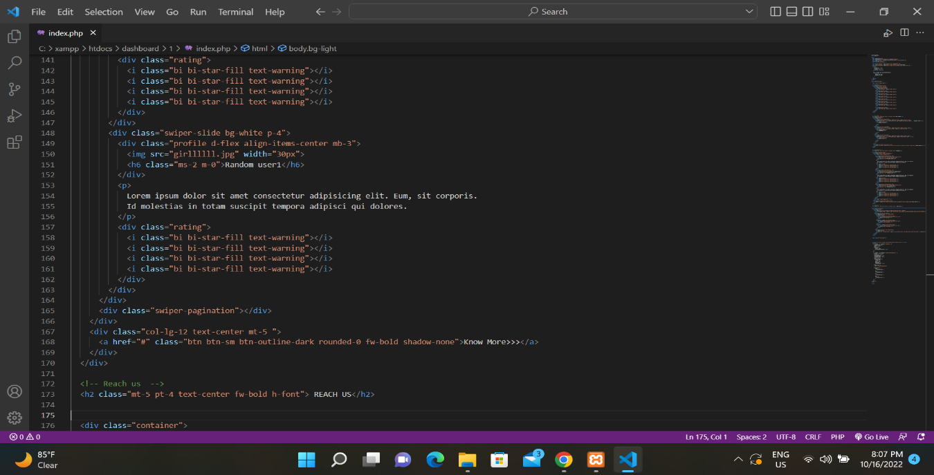

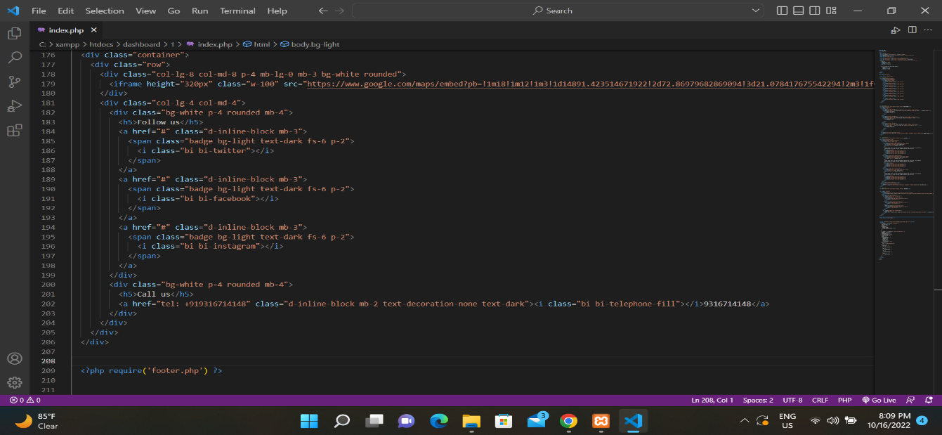

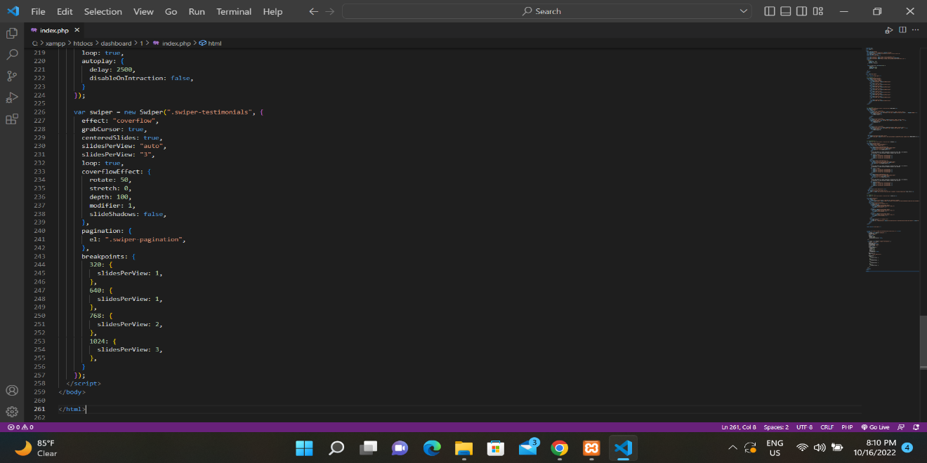

**Packages show**

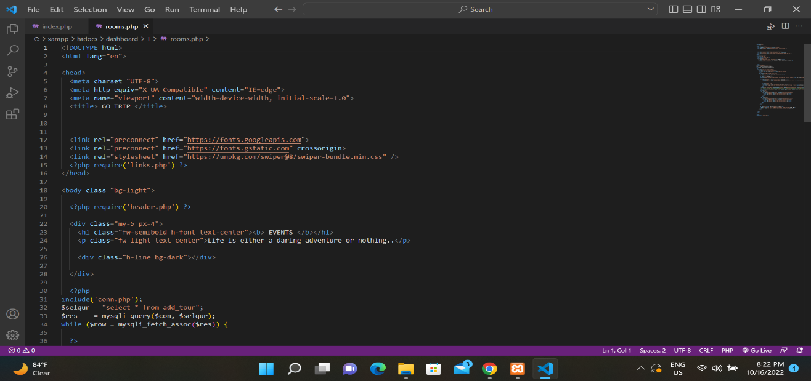

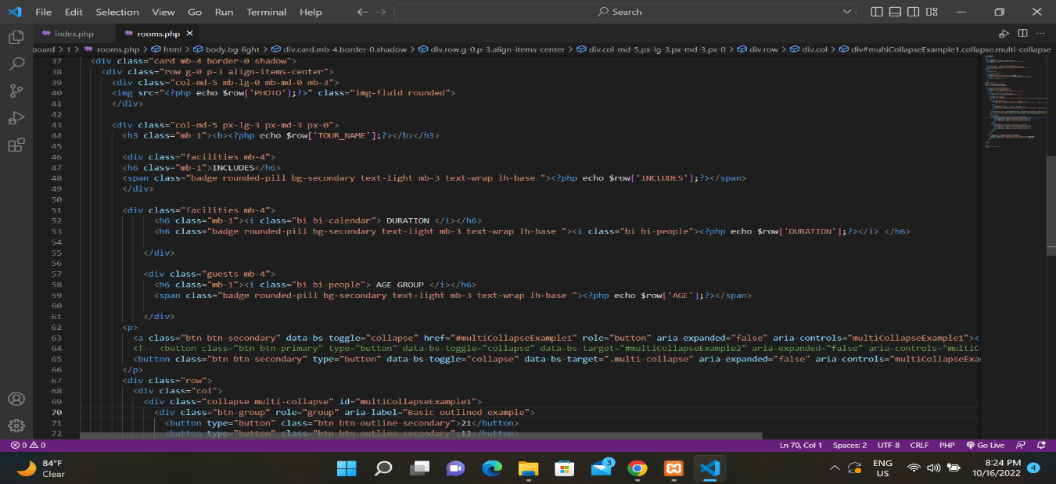

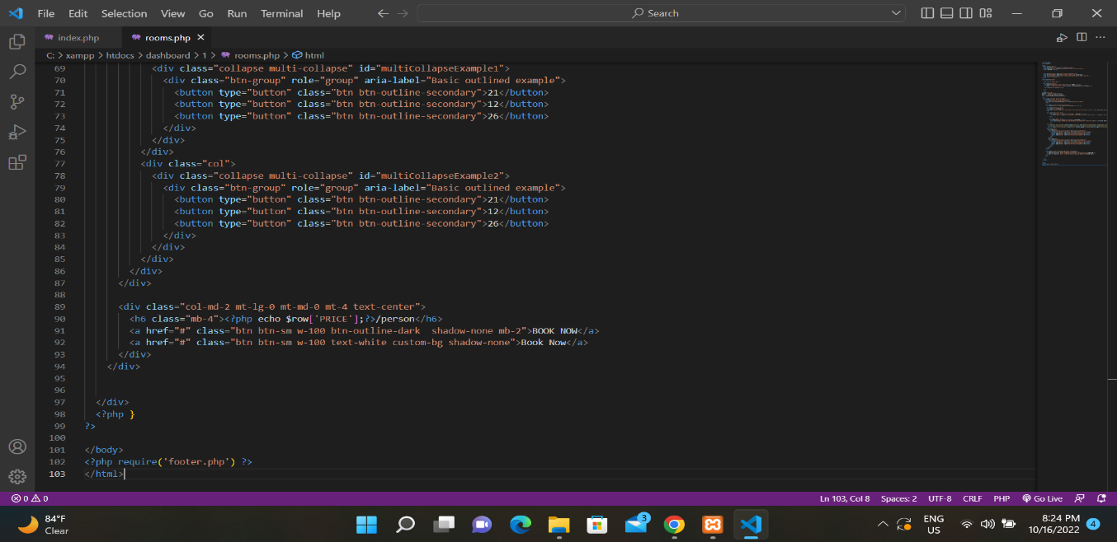

**Feedback page**

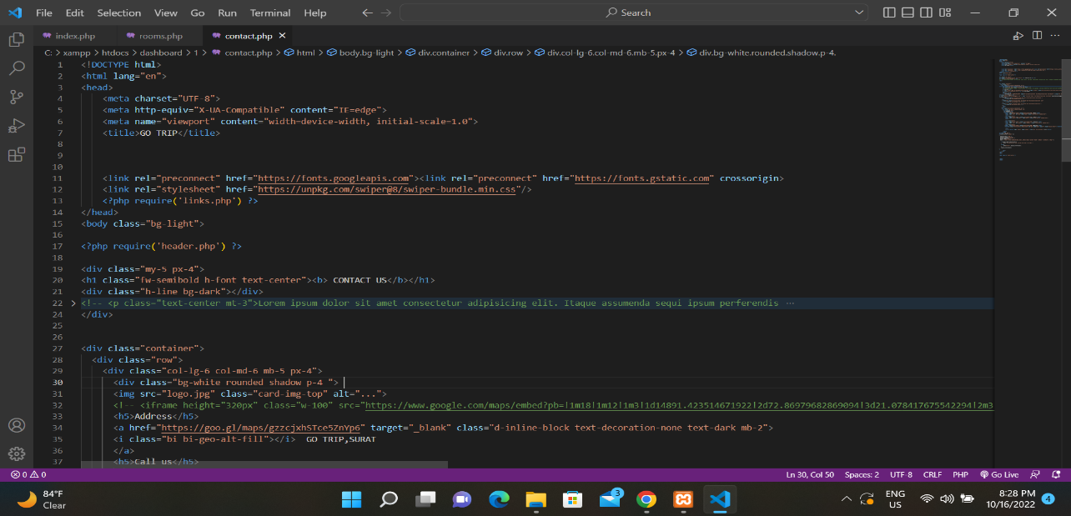

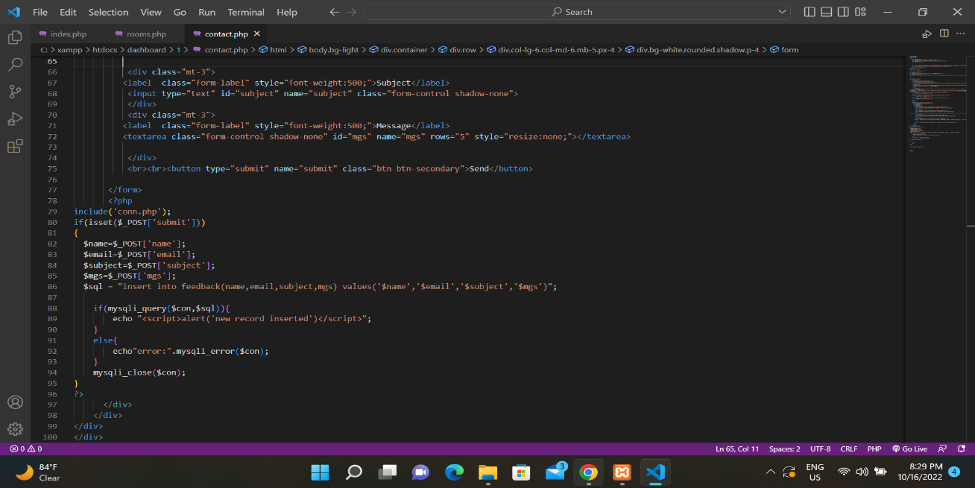

**About us**

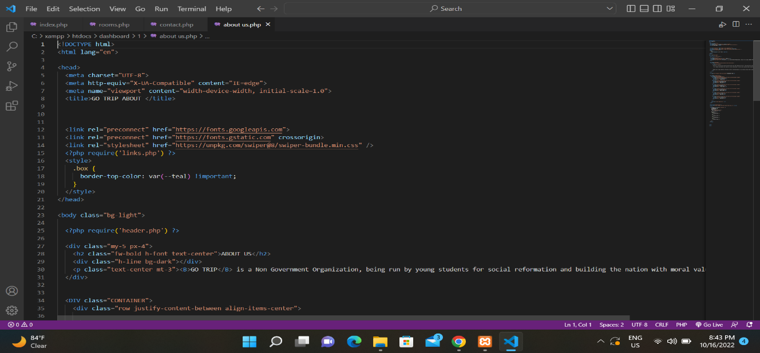

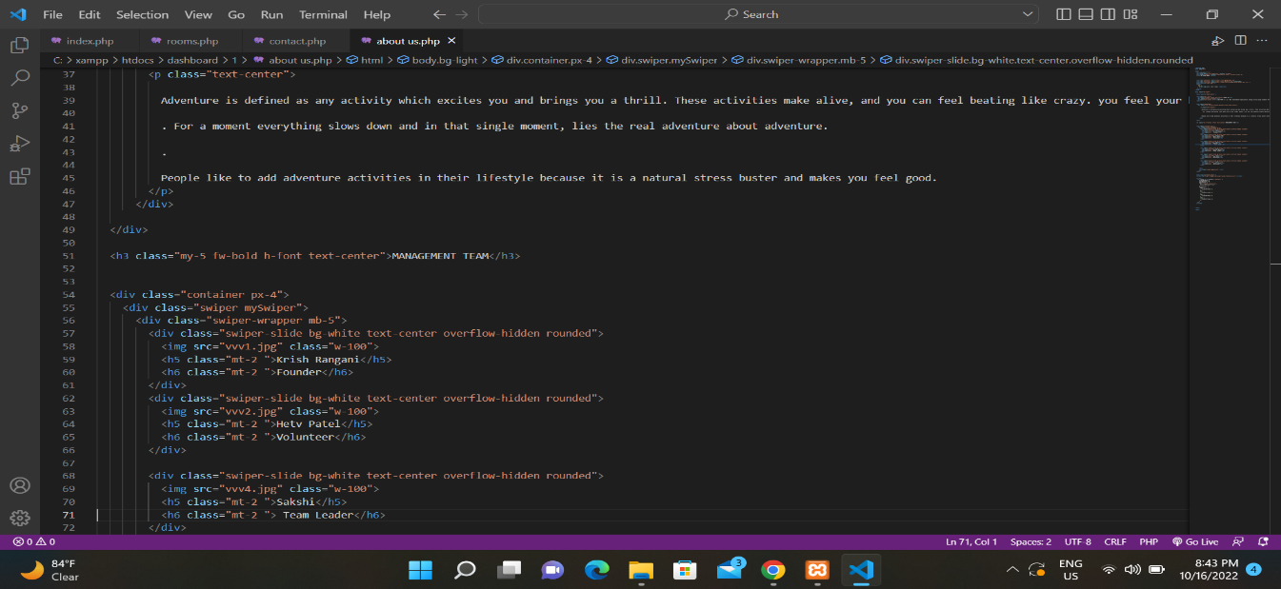

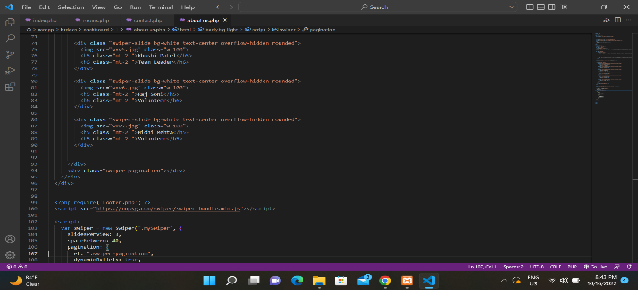

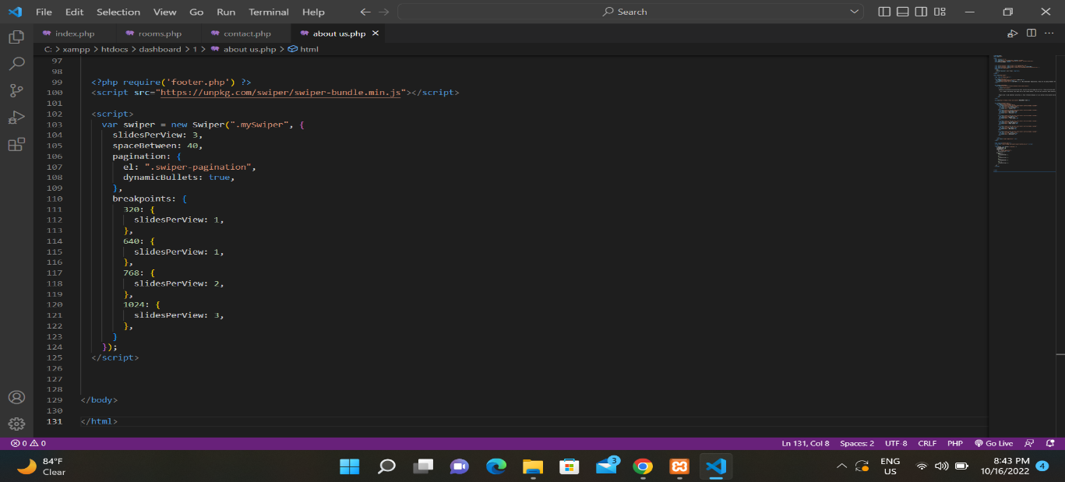

* + Db connection page

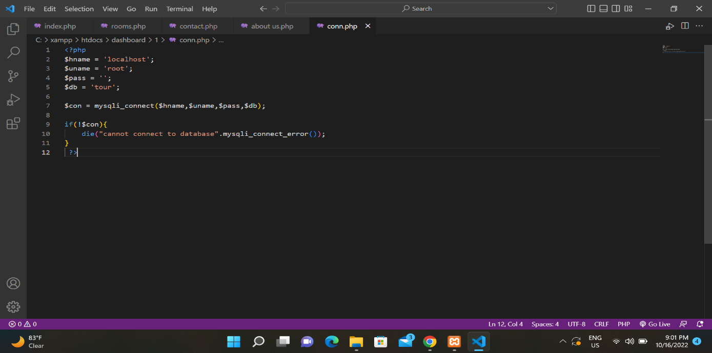

Login page

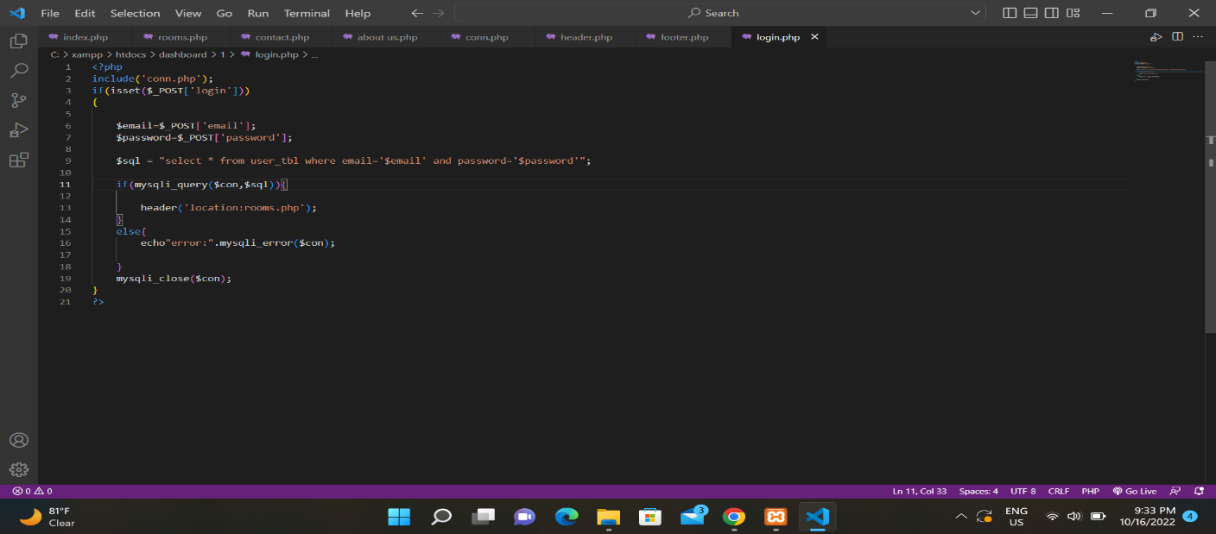

Header pagee

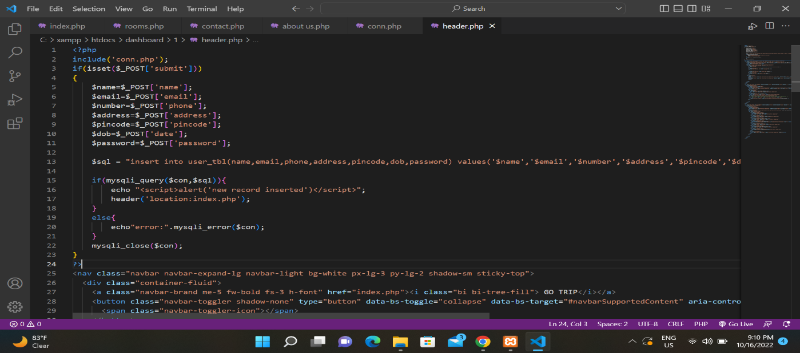

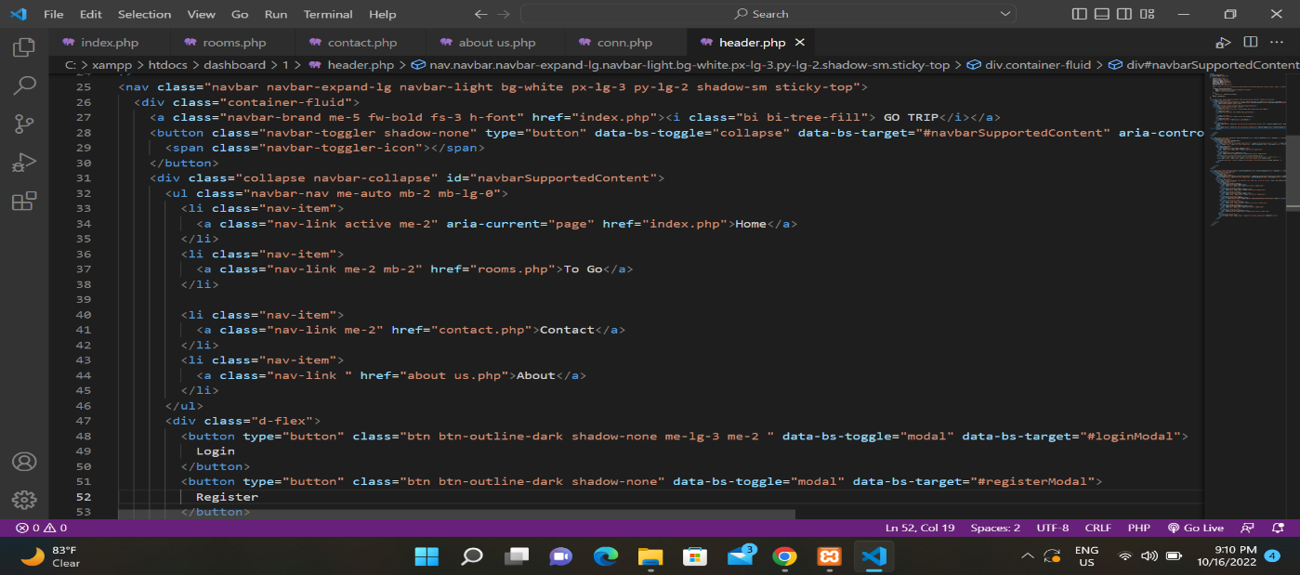

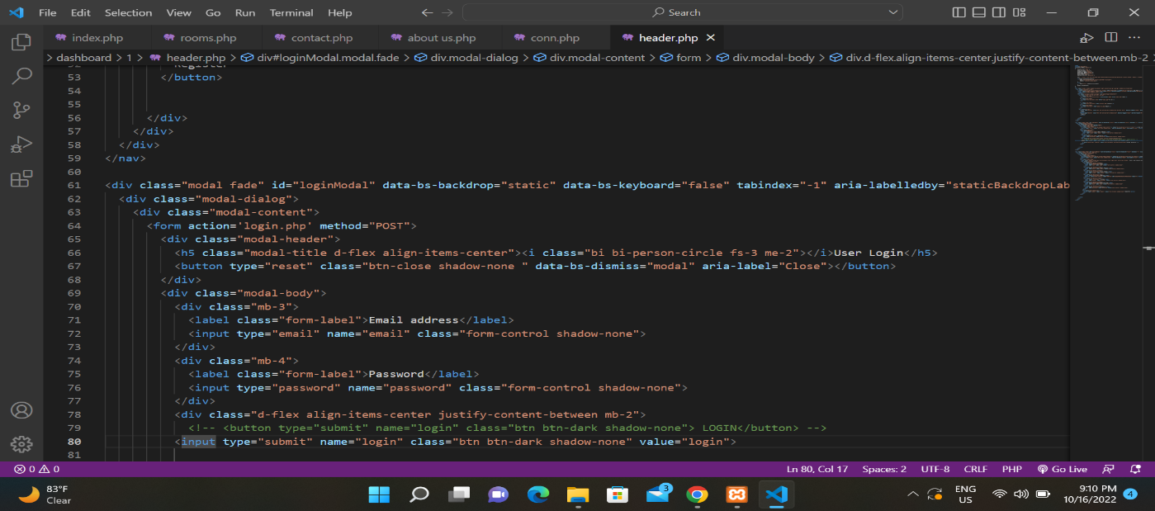

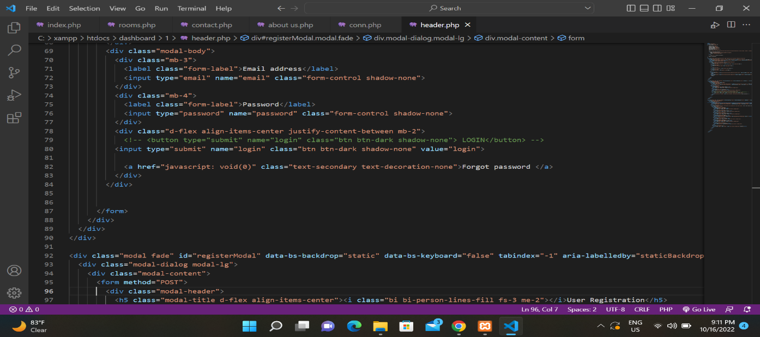

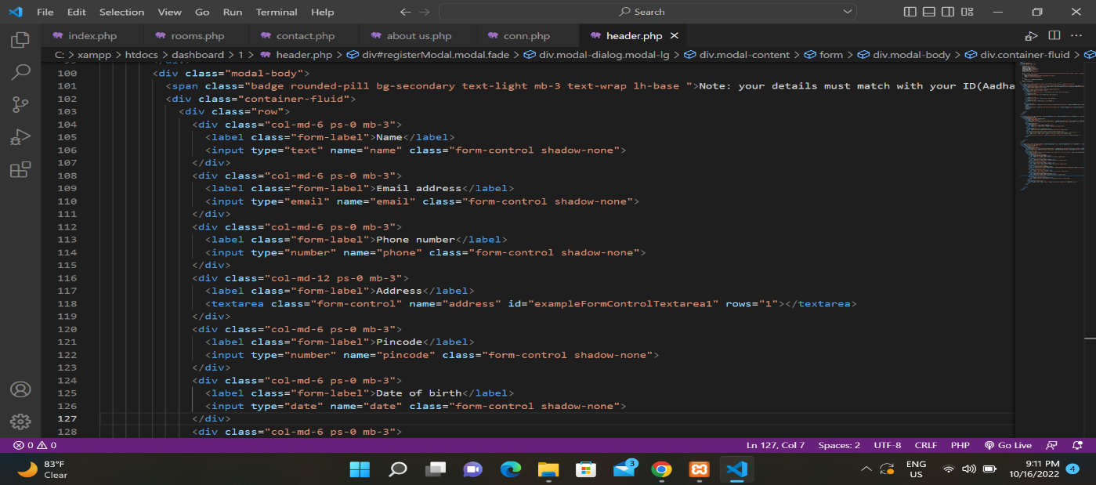

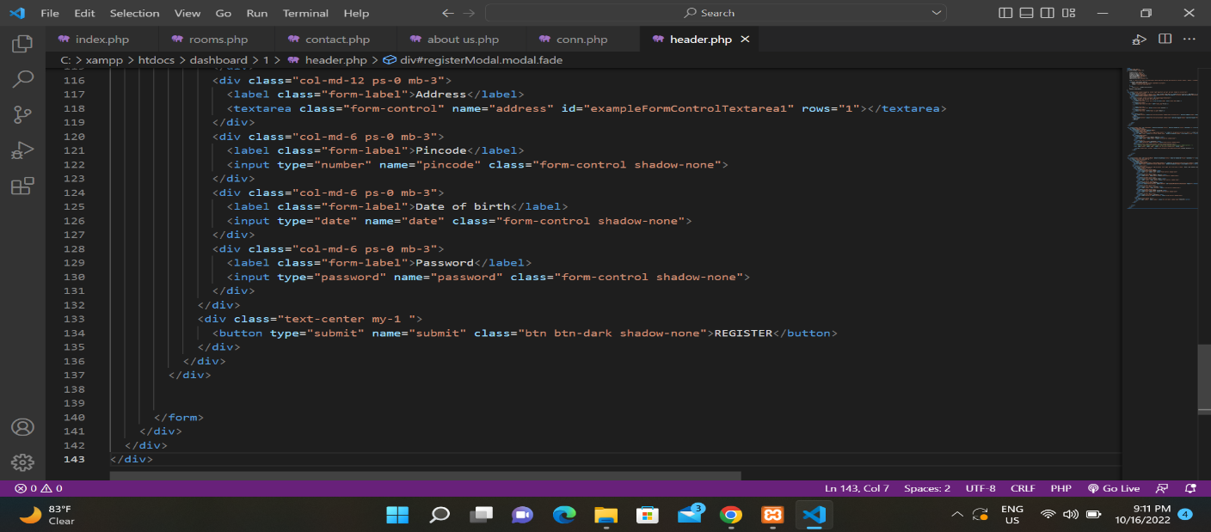

**Footer page**

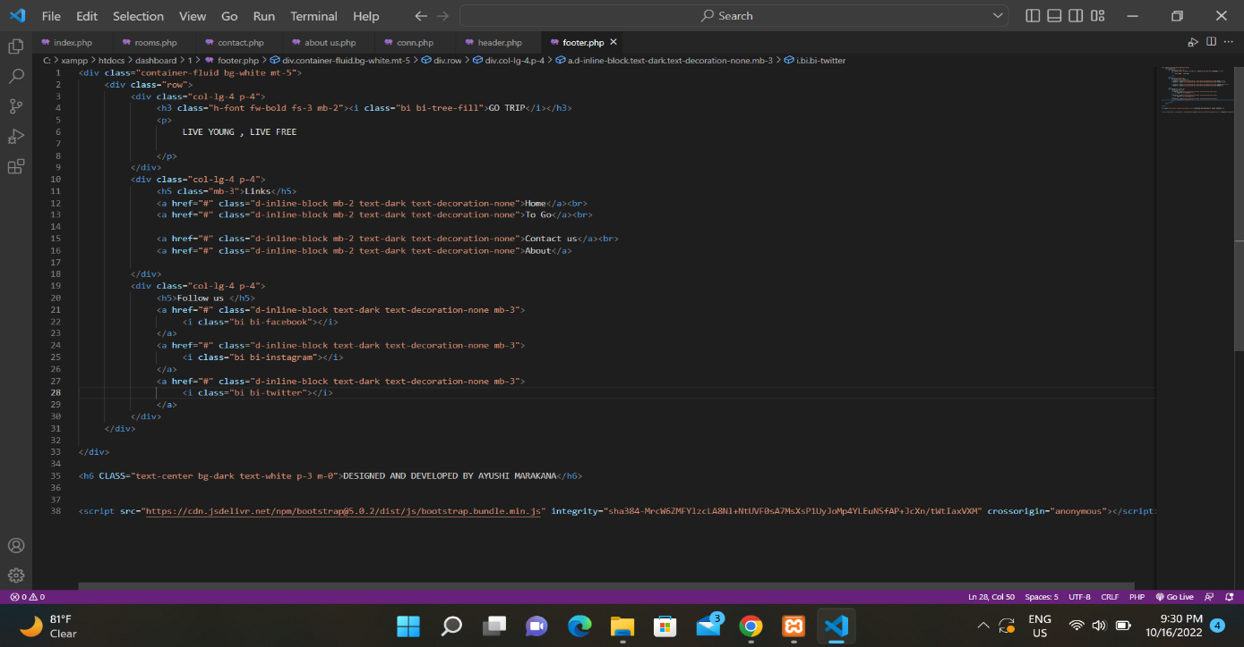

**Admin dashboard page**

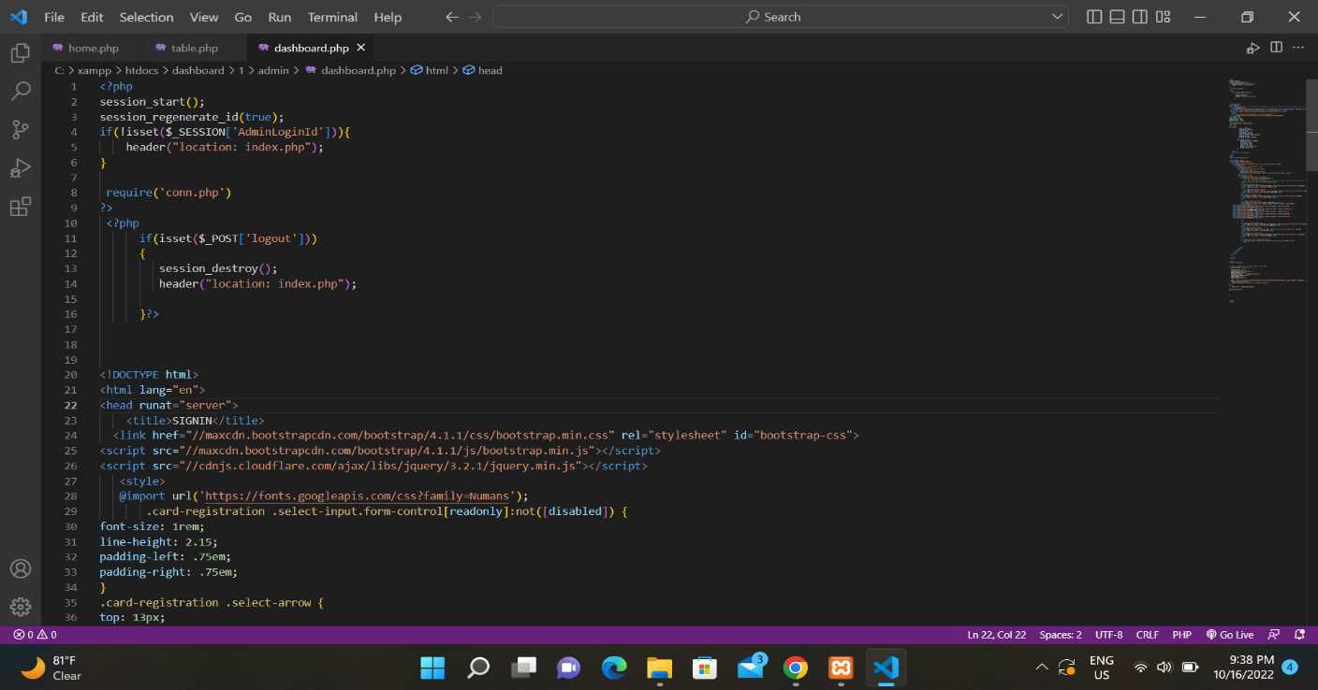

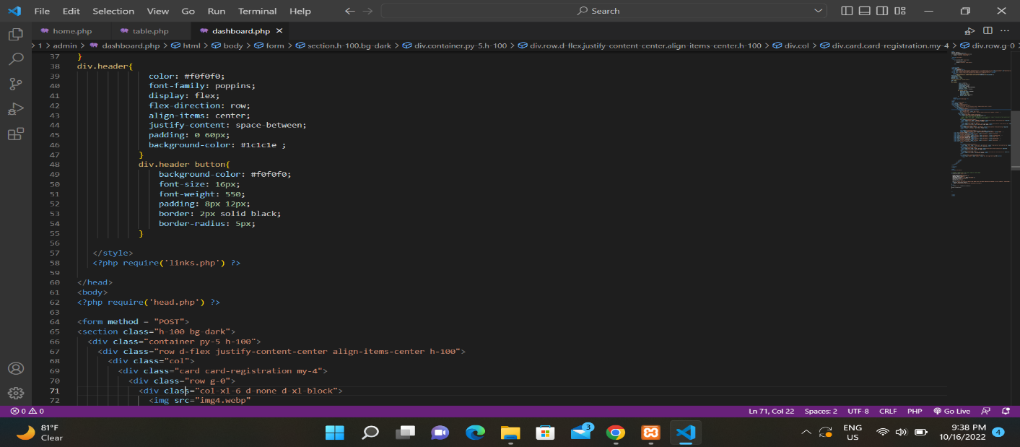

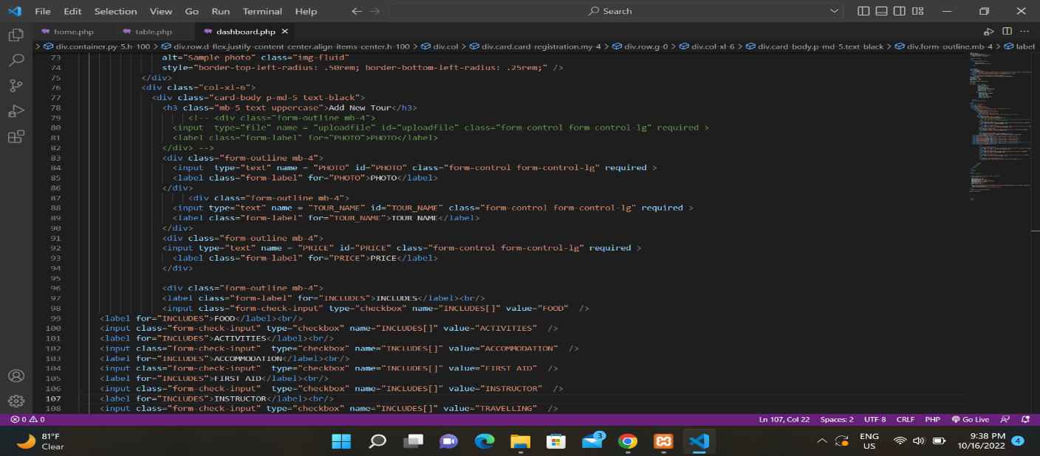

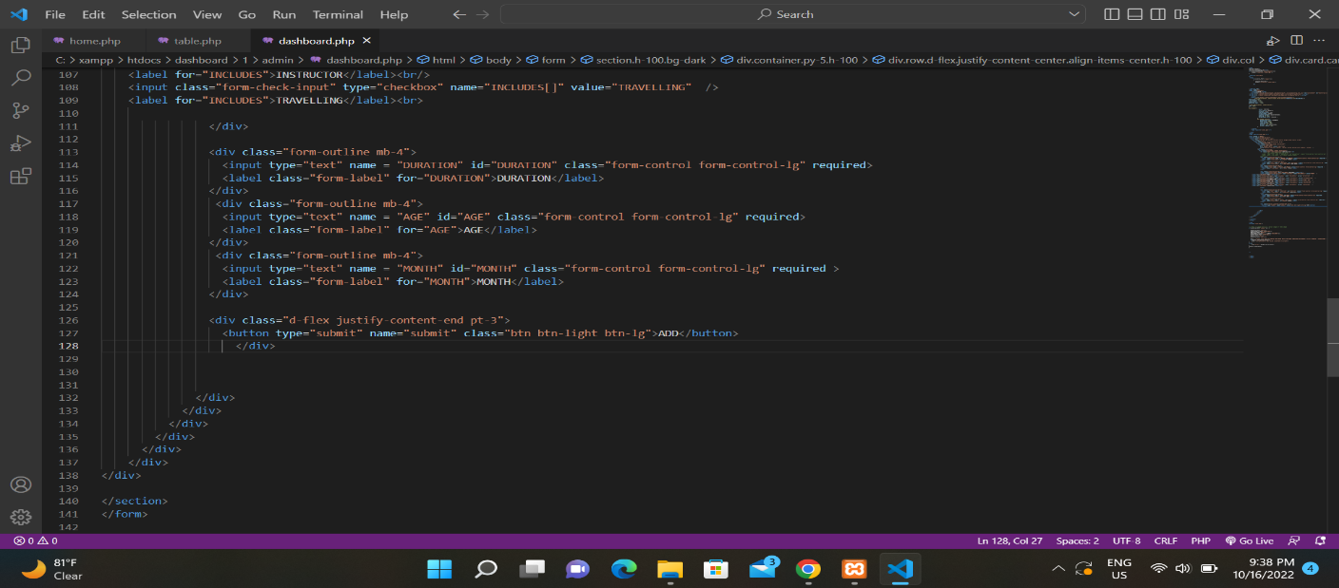

**Package update,delete table**

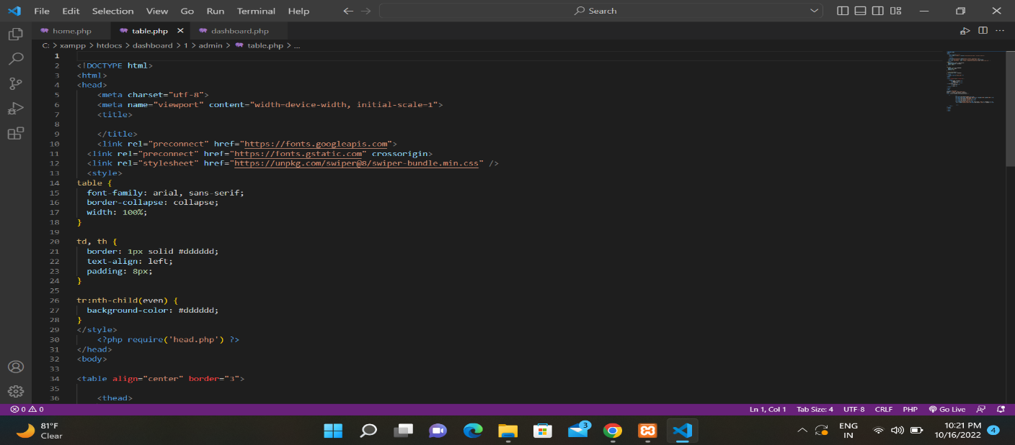

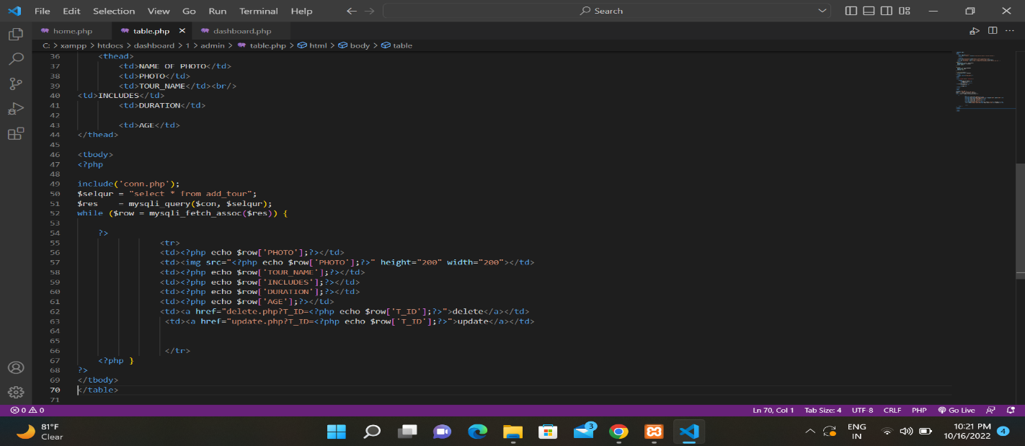

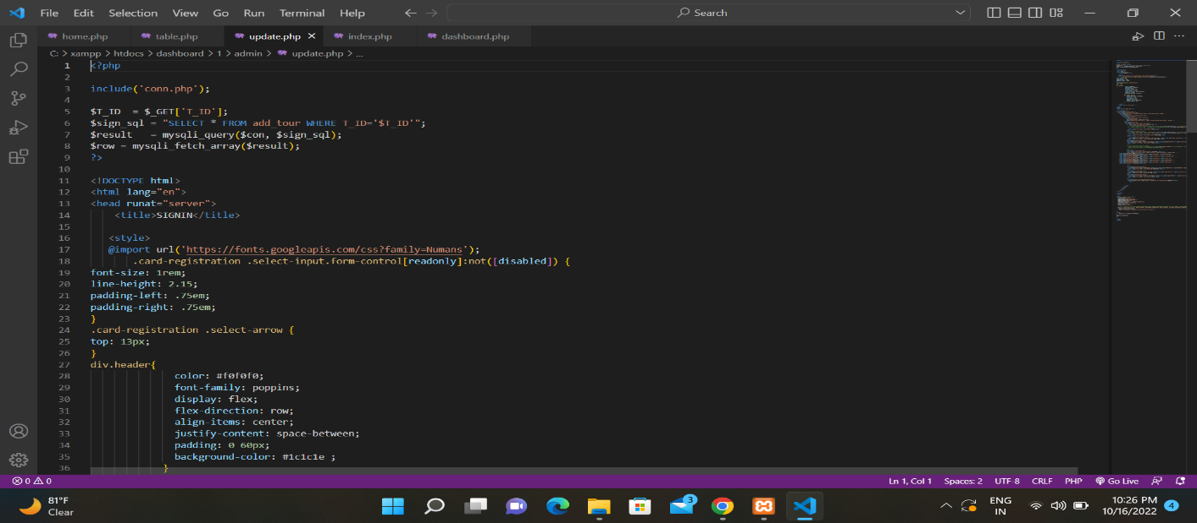

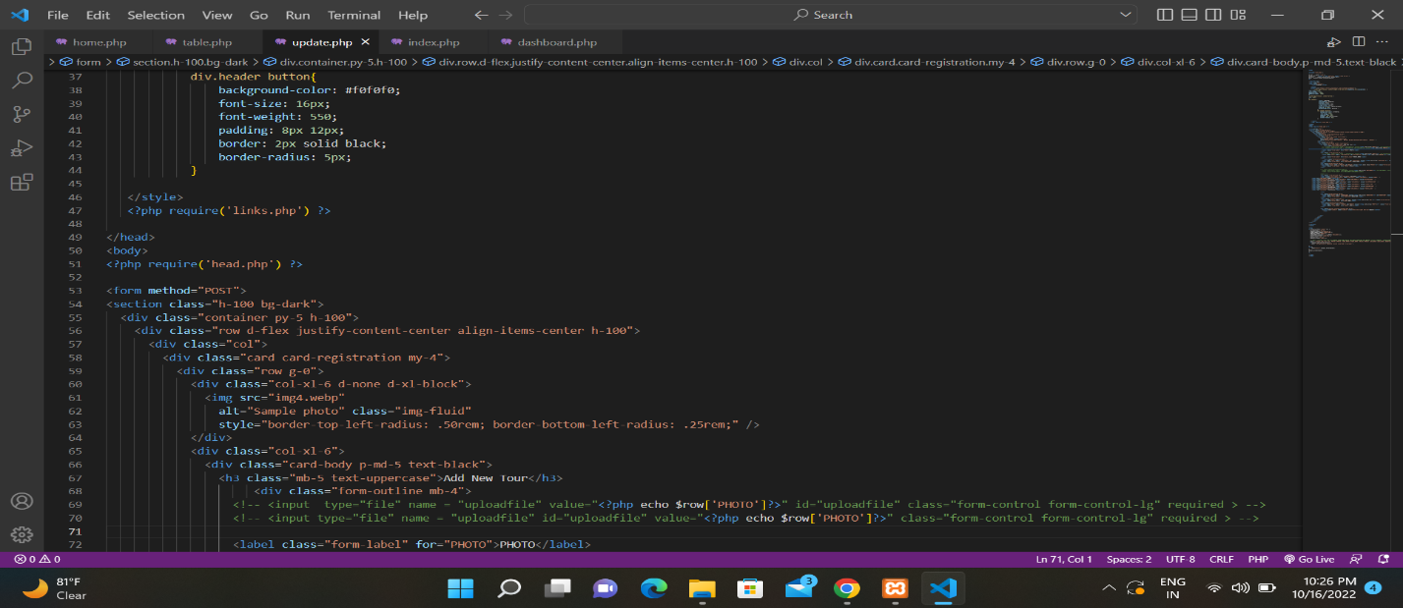

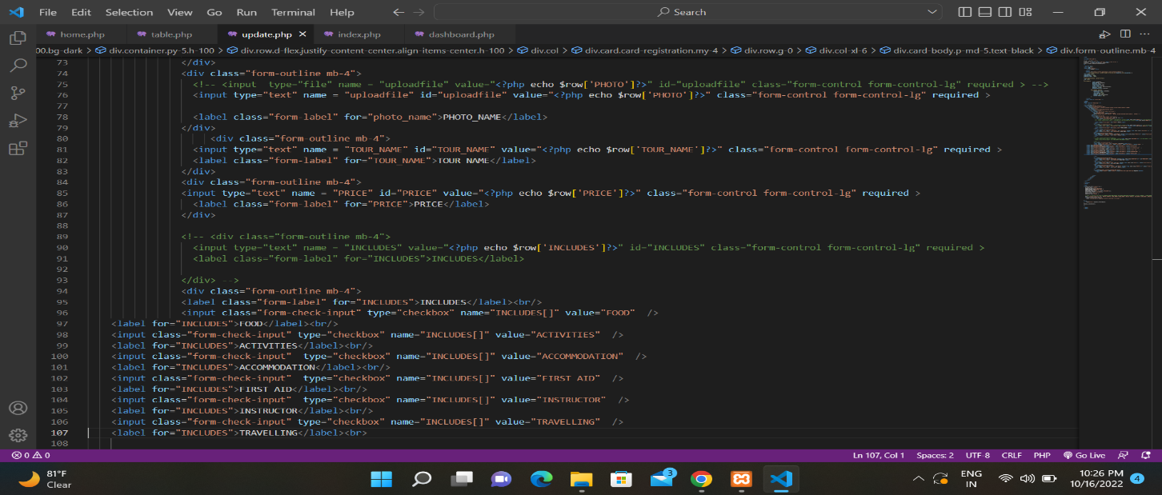

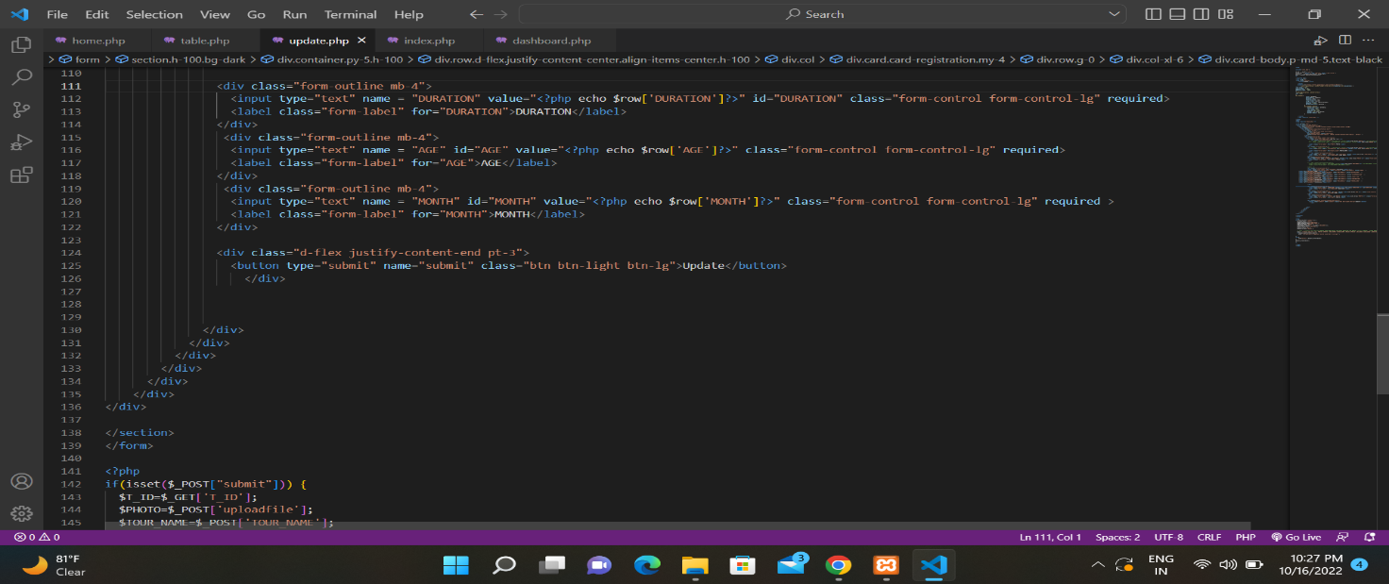

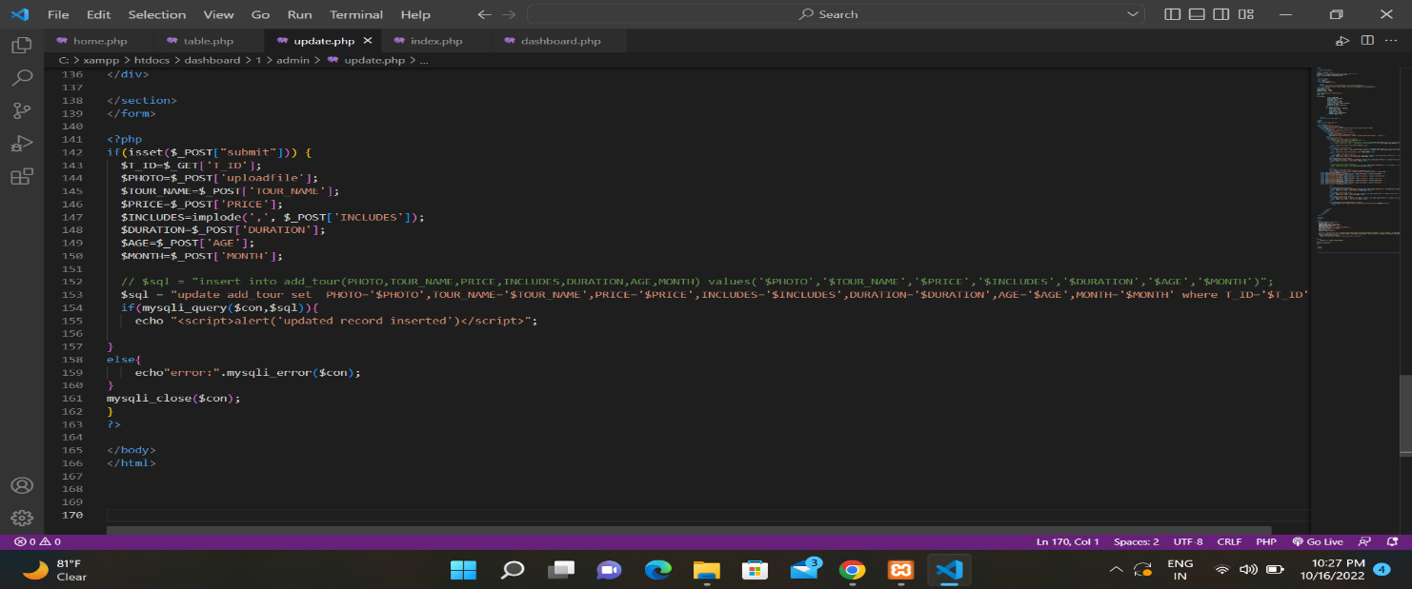

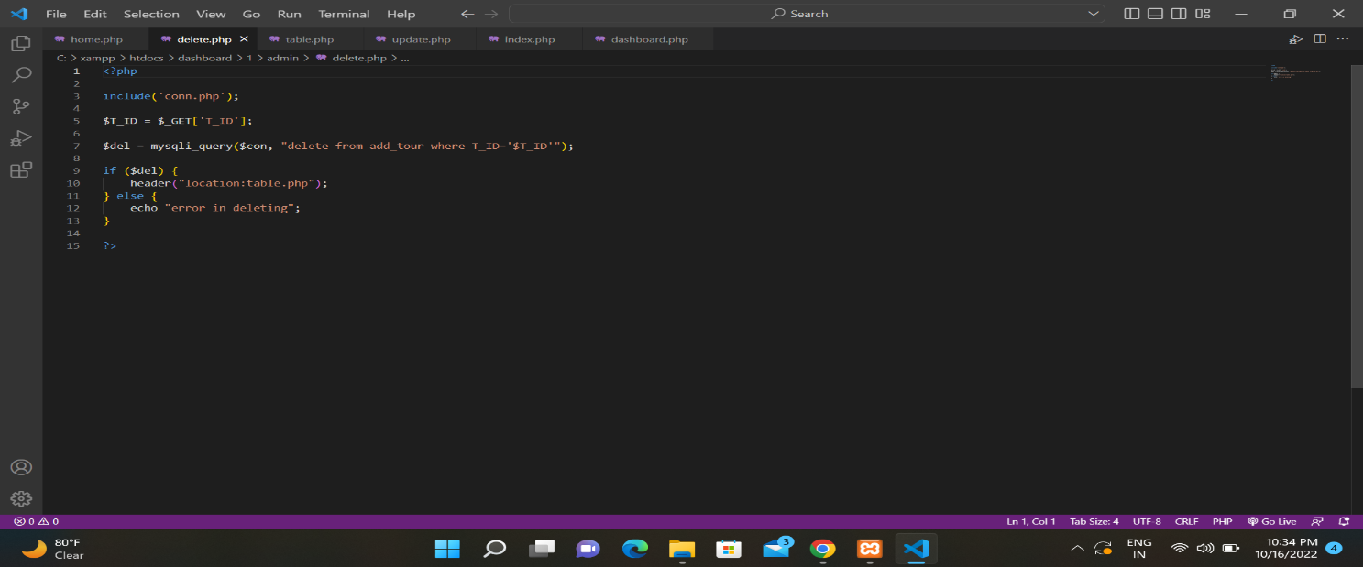  **add tour**

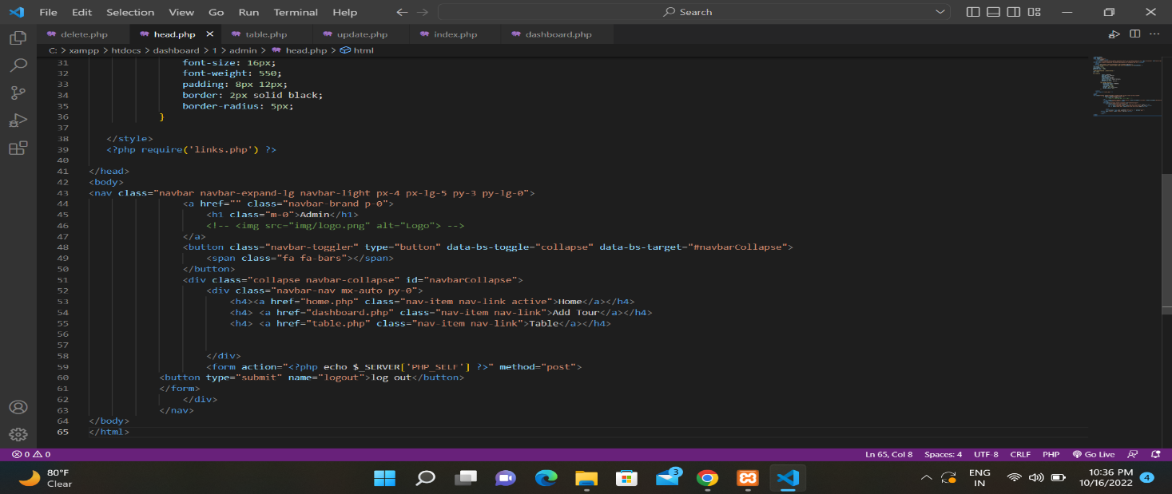

**Admin login**

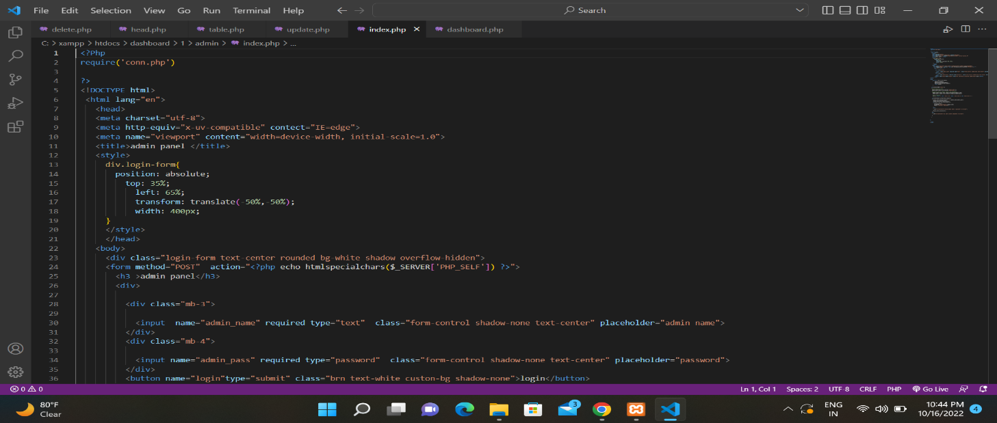

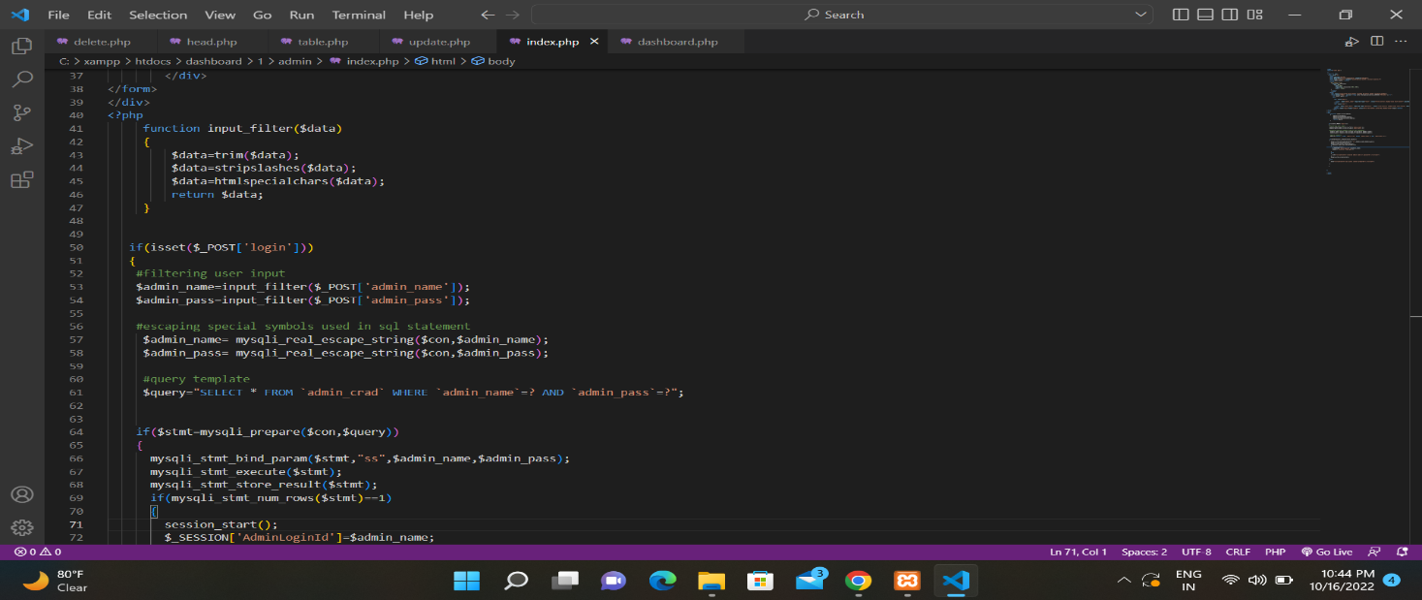

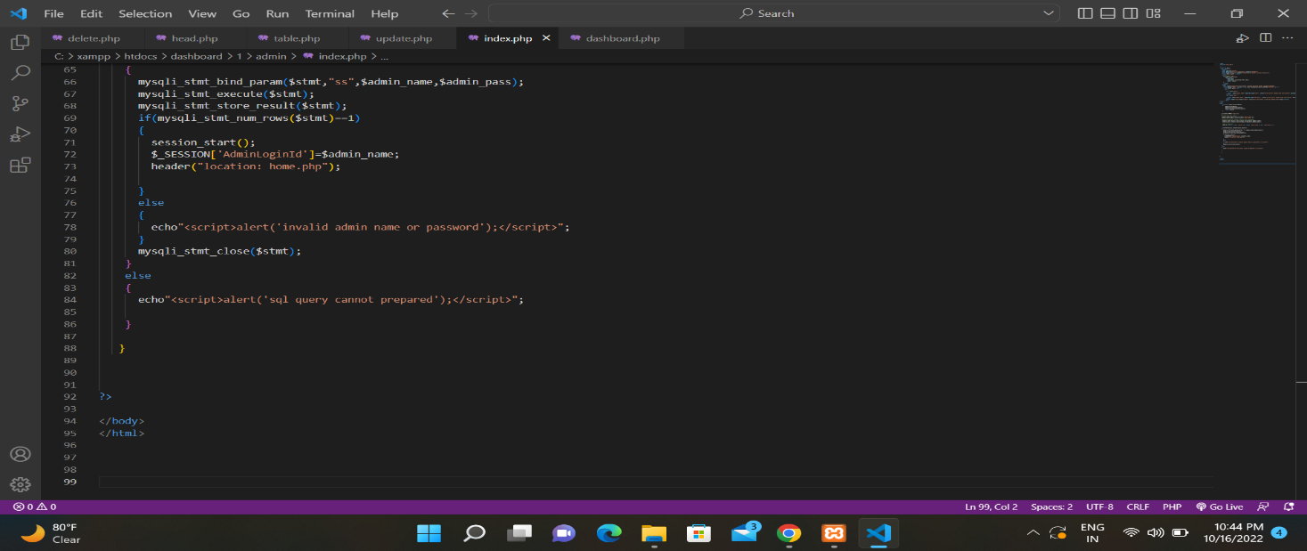

* 1. NEW TOOLS/ TECHNOLOGIES LEARNED/ USED:
     + Visual Studio 2019:- It is the main development environment in which we will Code.
     + Some CSS for page design
     + MYSQL Database.

1. SYSTEM LIMITATION/CONSTRAINTS::
   * + User only able to see their own details and do not able to see other user data.
     + Faculty member add by only admin
     + Can’t send email to registrated user.
     + Can’t make user Admit card.
2. Future Enhancement & Opportunities
   * More efficient design and user experience.
   * Apply More efficient constraints .
   * Add module of payment through customer .
   * Will send email to customer when successfully registered.
3. BIBLIOGRAPHY & REFERENCES:

**Website**

* [www.google.com](http://www.google.com)
* https://invinciblengo.org